

**LEVEL DESIGN DOCUMENT**

**Current Owner**: Stefano D’Ambra

The **purpose** of this document is to give information about the whole structure of the game, with an in-depth examination of the level “TRIWIZARD TOURNAMENT: CHIMAERA’S DUNGEON”.

|  |  |  |
| --- | --- | --- |
| Creation date: 19/10/20 14:49 | **REVISION HISTORY** | Last Modification: 06/11/20 15:59 |
| **WHO** | **WHEN** | **WHAT** |
| Niccolò Cappellini | 19/10/2020 14:49 | Document created |
| Ridiculus Boggarts | 23/10/2020 17:09 | First draft of the goal outline |
| Ridiculus Boggarts | 26/10/2020 17:00 | Updated goal outline |
| Stefano D’Ambra | 26/10/2020 19:10 | Added World Map |
| Niccolò Cappellini | 27/10/2020 19:05 | Added TOC, page numbers and Settings |
| Stefano D’Ambra | 27/10/2020 19:41 | Added World Diagram |
| Edoardo Carrer | 28/10/2020 20:00 | Added Themes |
| Niccolò Cappellini | 29/10/2020 9:45 | Added High Concept |
| Edoardo Carrer | 29/10/2020 19:30 | First draft of Synopsis |
| Stefano D’Ambra | 30/10/2020 01:12 | Added Story Flowchart |
| Edoardo Carrer | 30/10/2020 15:20 | Added Story Plot |
| Edoardo Carrer | 30/10/2020 18:10 | Added main storytelling elements |
| Edoardo Carrer | 31/10/2020 18:50 | Added Theodore Nott’s character section |
| Stefano D’Ambra | 01/11/2020 19:15 | Added Albus Dumbledore character section |
| Niccolò Cappellini | 01/11/2020 20:06 | Added Minerva Character section |
| Ridiculus Boggarts | 02/11/2020 16:05 | Added remaining characters |
| Ridiculus Boggarts | 02/11/2020 19:48 | Level script |
| Ridiculus Boggarts | 06/11/2020 15:59 | Revision |

**HIGH CONCEPT** **Errore. Il segnalibro non è definito.**

**WORLD MAP**7

**SETTINGS**8

DIAGON ALLEY 8

KING’S CROSS STATION **Errore. Il segnalibro non è definito.**

HOGWARTS CASTLE 8

Great Hall 9

Transfiguration Class 9

Potion Class 9

Spell Class 9

Exercise Room 9

Dumbledore Office 9

Library 10

Dormitory 10

FORBIDDEN FOREST 10

TOURNAMENT CAMP **Errore. Il segnalibro non è definito.**

TRIWIZARD ARENA **Errore. Il segnalibro non è definito.**

NOTT’S HIDEOUT 12

**SYNOPSIS**12

ACT 1 13

ACT 2 13

ACT 3 13

ACT 3.1: Minerva wants to protect Dumbledore 13

ACT 3.2: Minerva wants to follow Nott's plan 13

**STORY PLOT**13

**MAIN STORYTELLING ELEMENTS**14

**STORY FLOWCHART**16

**THEMES**18

**CHARACTERS**18

MINERVA MCGONAGALL **Errore. Il segnalibro non è definito.**

DESCRIPTION 19

CIRCUMPLEX 19

RELATIONSHIP MAP 20

ALBUS DUMBLEDORE 20

DESCRIPTION 21

CIRCUMPLEX 21

RELATIONSHIP MAP 21

THEODORE NOTT 23

DESCRIPTION 24

CIRCUMPLEX 24

RELATIONSHIP MAP 25

JACQUES DUGARD 26

DESCRIPTION 26

CIRCUMPLEX 26

RELATIONSHIP MAP 27

ASTRID STORMO 28

DESCRIPTION 28

CIRCUMPLEX **Errore. Il segnalibro non è definito.**

RELATIONSHIP MAP 29

**WORLD DIAGRAM**30

**GOAL OUTLINE**31

**LEVEL SCRIPT**32

# 

# 

# 

# 

# 

# 

# 

# 

# 

# HIGH CONCEPT

The game follows the story of the first year of school of Minerva McGonagall, a young, powerful but inexperienced witch who will find herself facing unexpected situations caused by Theodore Nott, a death eater from the future. Nott's intent is to convert Minerva to the dark side to make an attempt on the life of Albus Dumbledore. During the progression of the story, the player will have to make moral choices that will lead Minerva to prefer Albus (the good) to Nott (the bad) or vice versa. The adventure will take place mainly in Hogwarts and its surroundings, both well-known and new locations will be presented. The rules of the game are based on the fifth edition of Dungeons & Dragons, the game genre will be a rpg with isometric camera and turn-based combat with the ability to overcome certain situations using stealth mechanics.

Theodore Nott Minerva McGonagall Albus Dumbledore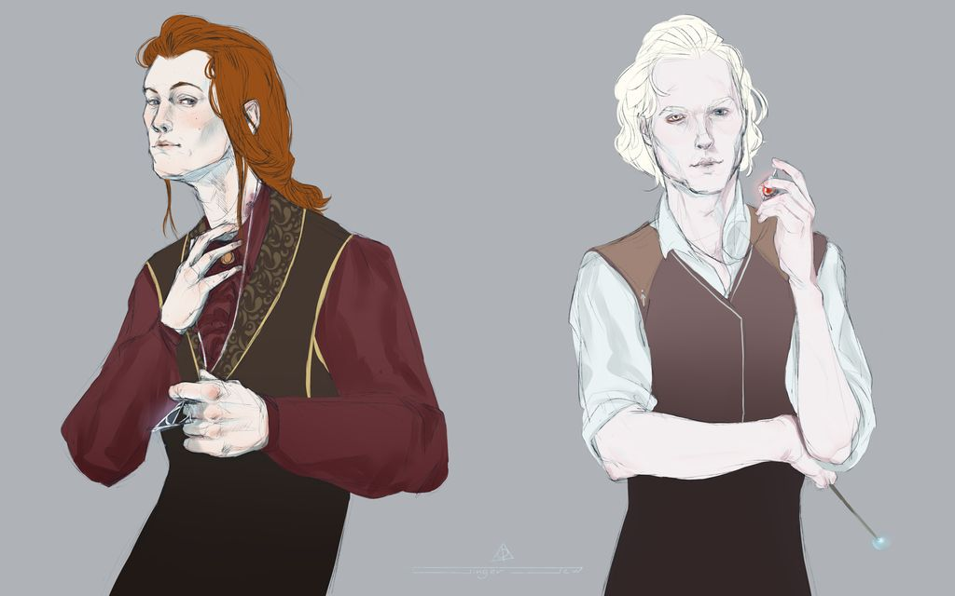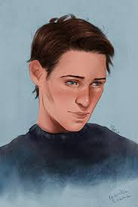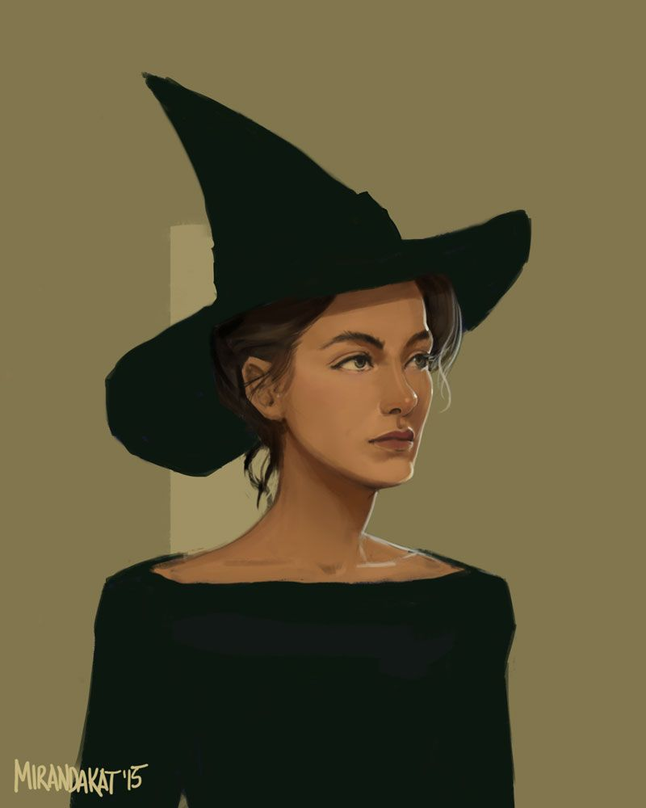

# WORLD MAP

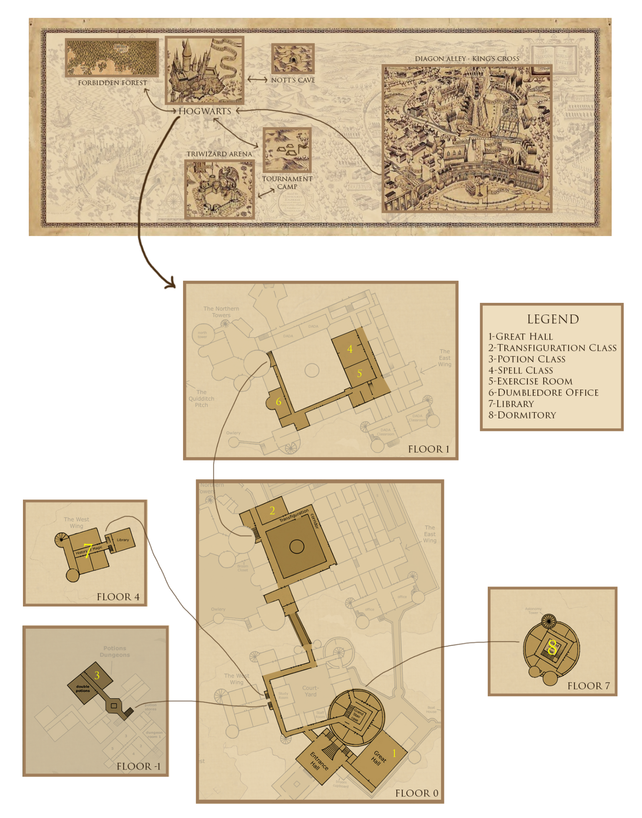

# 

# 

# SETTINGS

The story shows some of the most important events that happens to Minerva during her first year of school at Hogwarts, from the very first day of school where, walking down the streets of Diagon Alley, she will buy all the items necessary to start the school year, moving from ordinary situations of school life to unusual situations such as venturing into the forbidden forest or taking part in the Triwizard Cup.

## 

## DIAGON ALLEY

Diagon Alley is a secret alley located in London behind a pub called the Leaky Cauldron. The alley is a shopping area for wizards that contains shops, restaurants and other places of interest. There it's possible to buy all the items required for Hogwarts, from the uniform from the Madam Malkin's Robes for All Occasions to the first wand from Ollivander's.

## 

## 

## KING’S CROSS STATION

King's Cross Station is one of the main train stations in London, it's used by wizard students to take the Hogwarts Express that takes them to the homonymous school. The train can be reached by crossing Platform 9¾, a secret Platform hidden in a wall between platforms 9 and 10.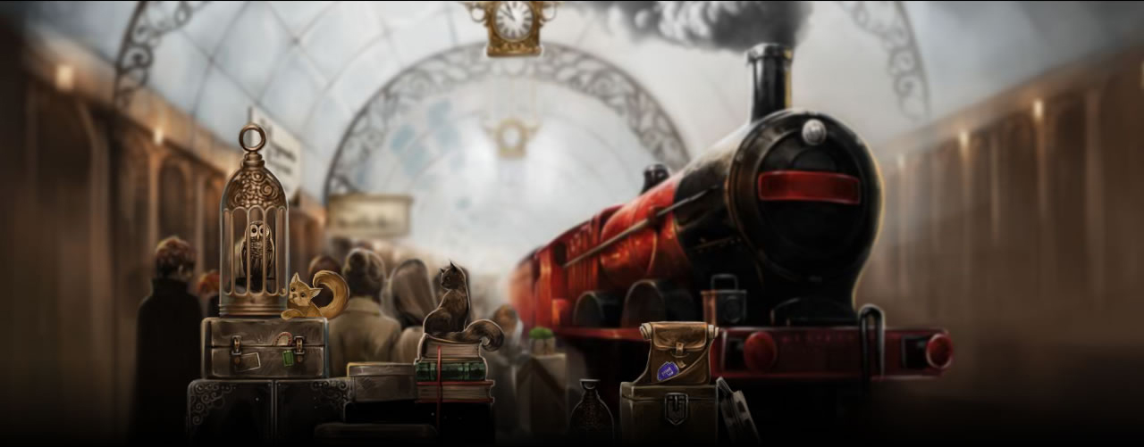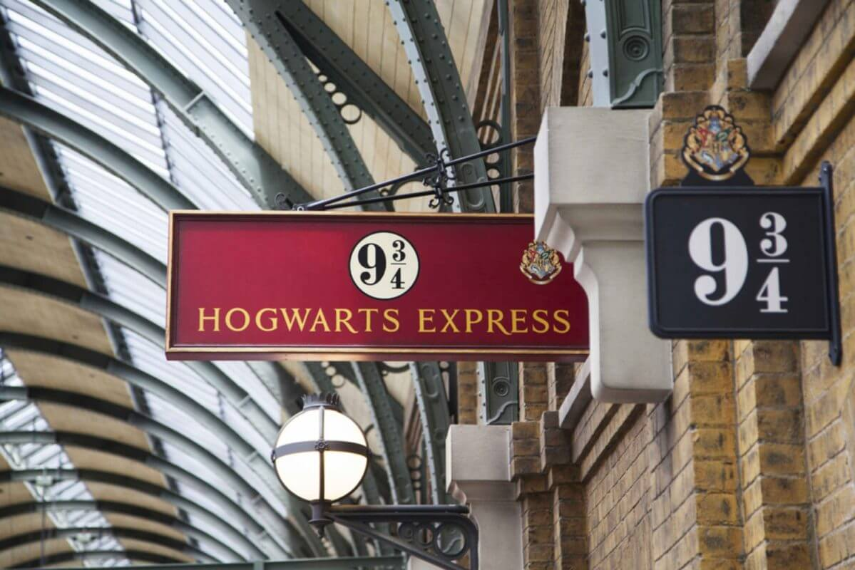

## 

## 

## 

## HOGWARTS CASTLE

Hogwarts Castle is a school of magic located in the scottish highlands. All magicians from England and Ireland come to study at Hogwarts. It is not a simple castle, in fact it is enchanted to hide from the sight of the Muggles and protect themselves from the dark forces.

### 

### Great Hall

The Great Hall is the main gathering area in the school. It's the room for special events, such as the Sorting ceremony and for announcements. It's also used as a canteen and as a place of aggregation.

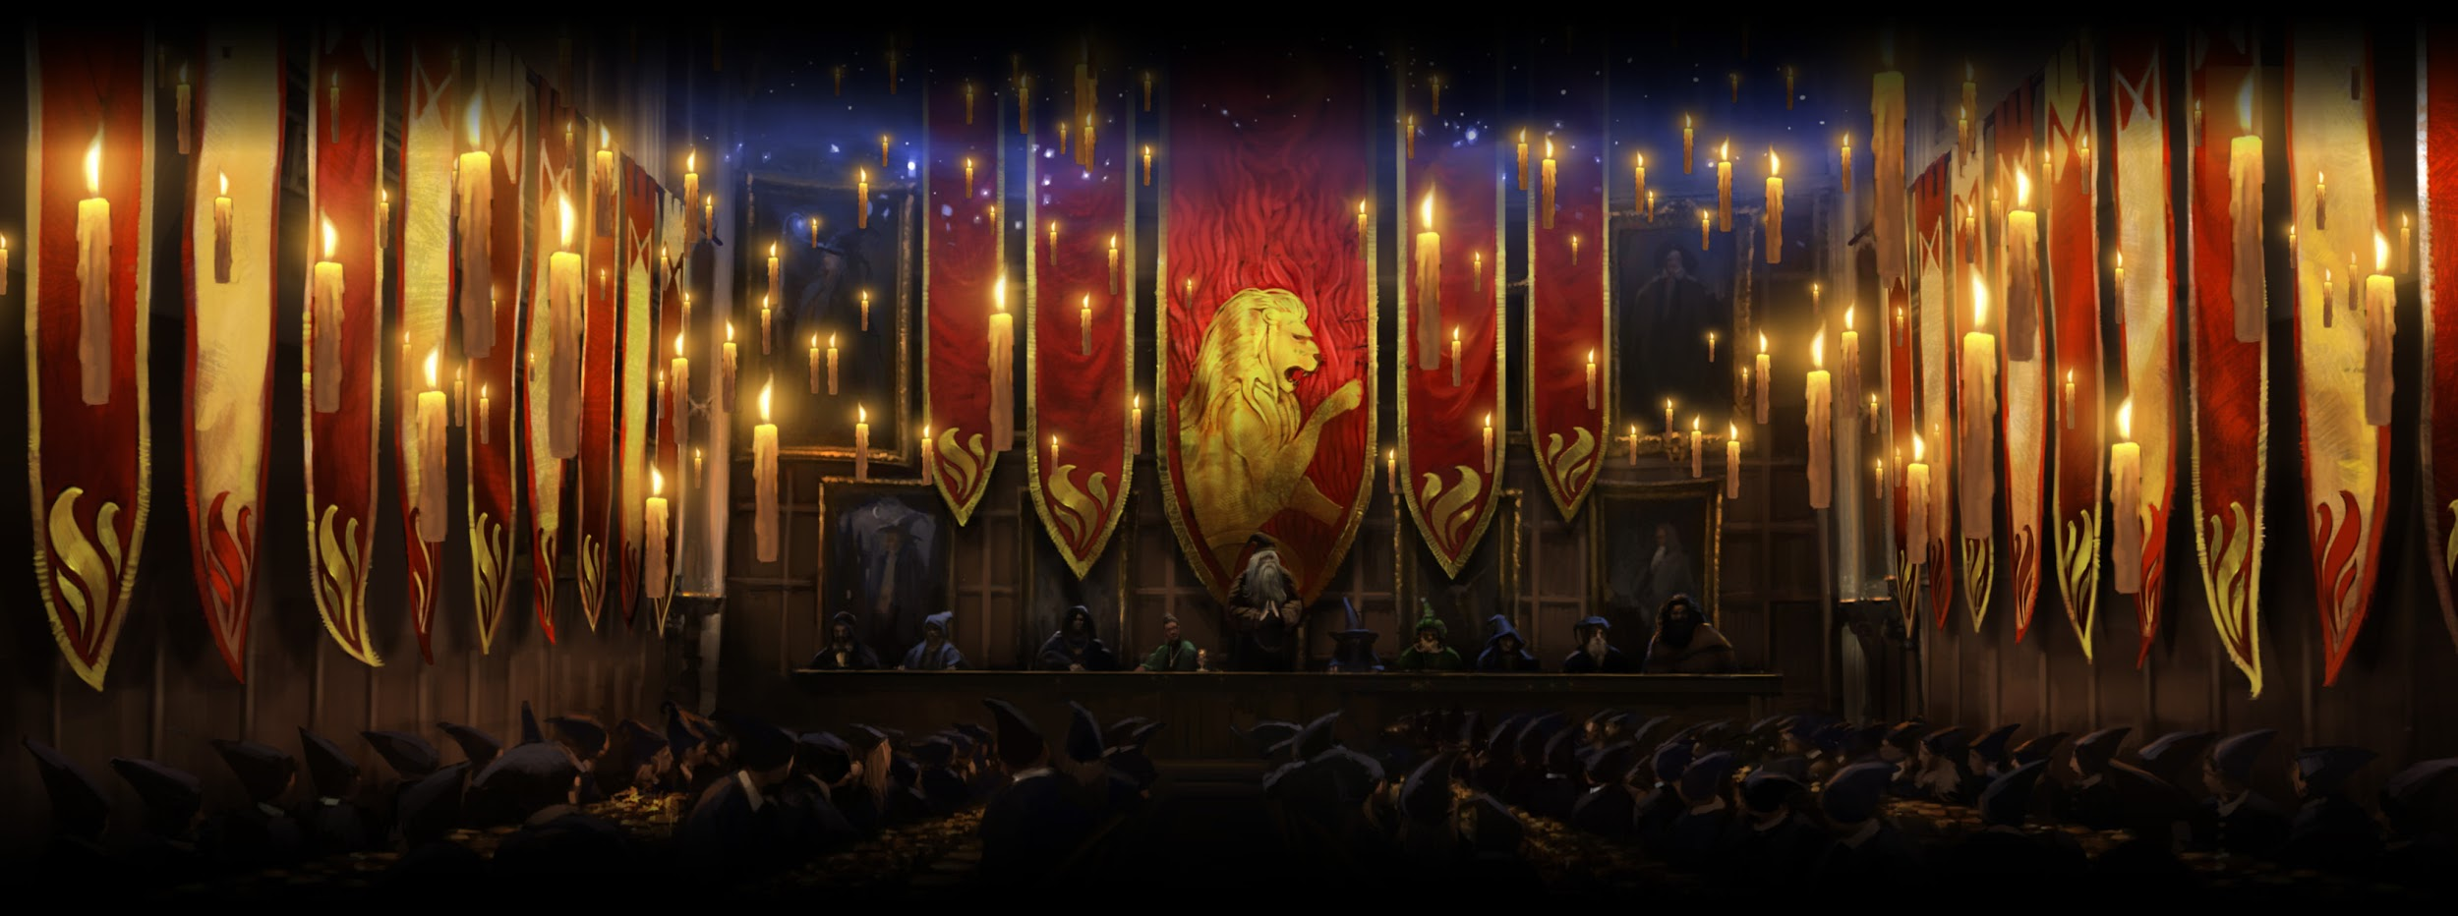

### Transfiguration Class

Transfiguration Class is the room where the transfiguration subject is taught. Here it is possible to learn how to change the appearance of an object or a person.

### Potion Class

Potion Class is the room where wizards learn how to correctly brew potions. The classroom provides students with all the ingredients needed to create the potions.

### Spell Class

Spell Class is the room where students learn how to defend themselves against all types of danger from harmful creatures to duelling other wizards.

### Exercise Room

In the exercise room students are free to practice the magical arts without the risk of hurting anyone.

### 

### 

### Dumbledore Office

It's the personal room of the professor Albus Dumbledore, where he spends part of his time when he is not lecturing.

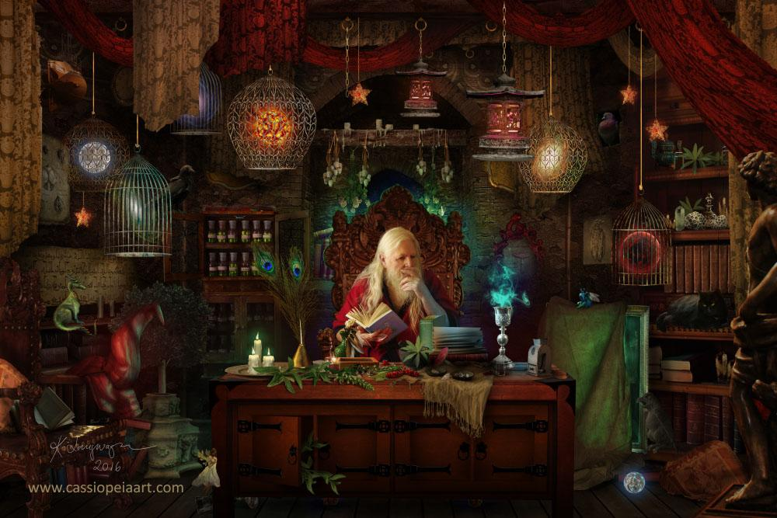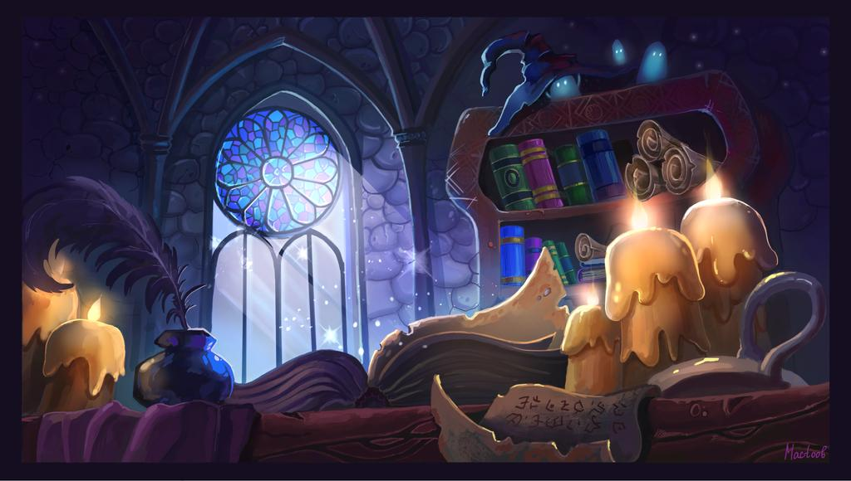

### Library

The library contains tens of hundreds of books dealing with the magical arts. Here students can study or borrow books when necessary. Inside the library there is a forbidden section that contains books that are rare and/or considered inappropriate for younger students (dealing with the dark arts).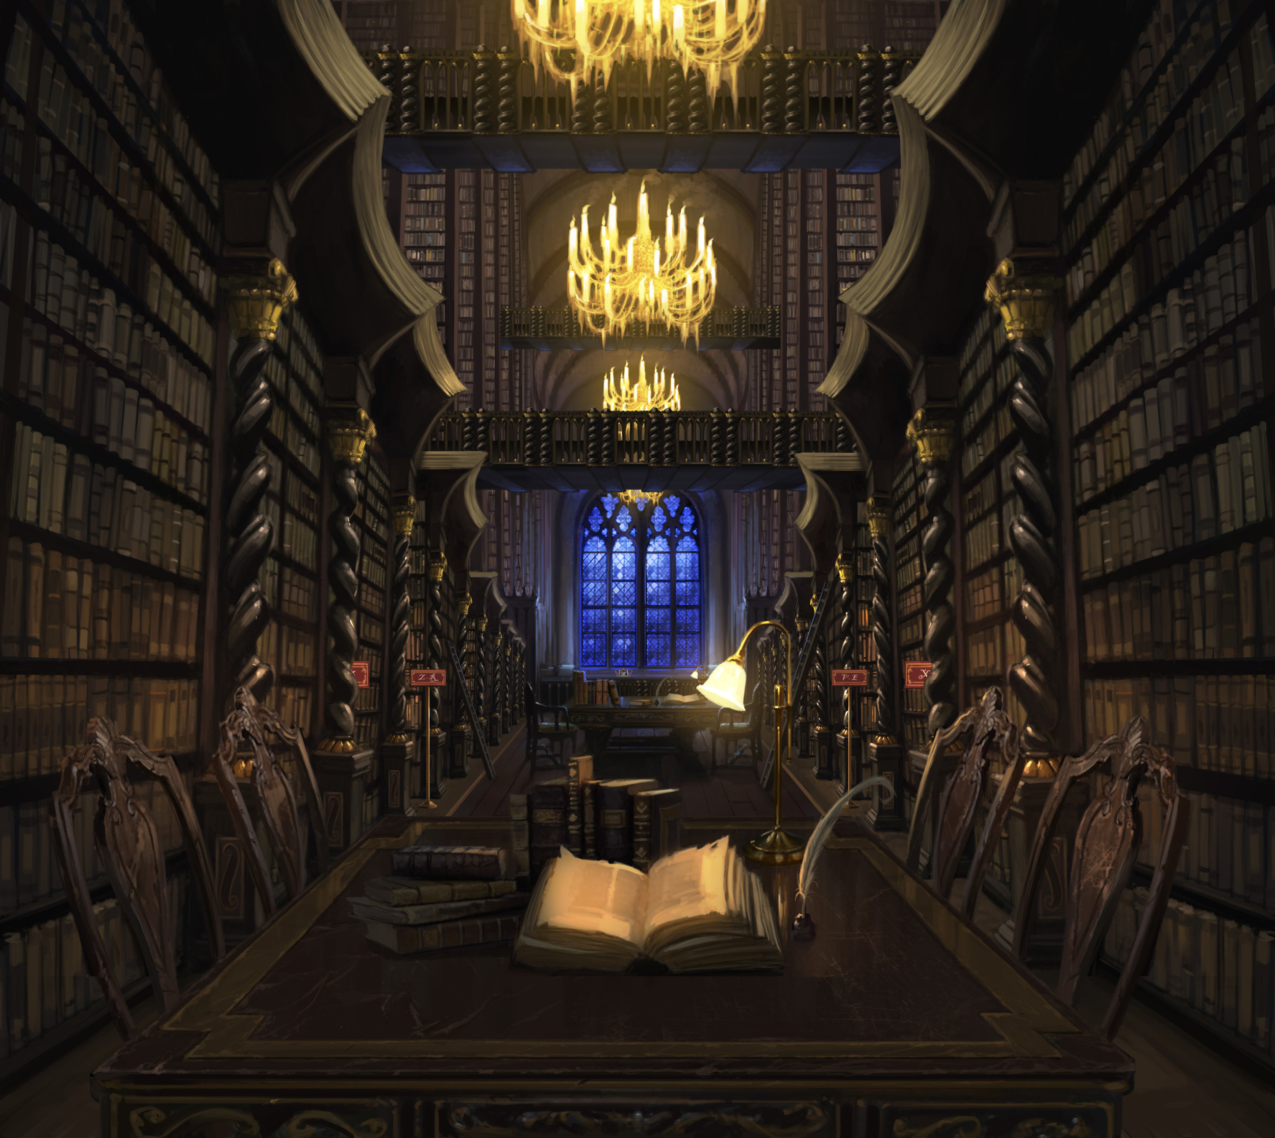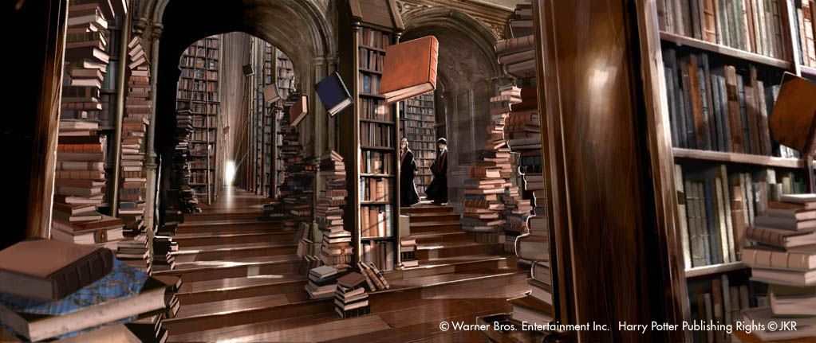

### Dormitory

The dormitory is the area where magicians rest during the night.

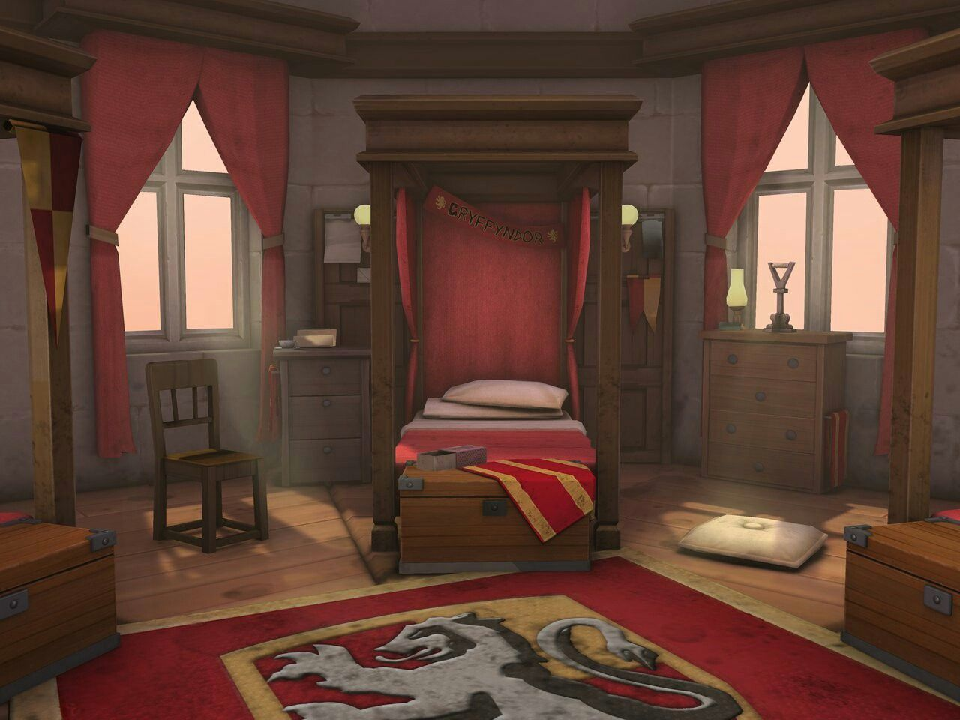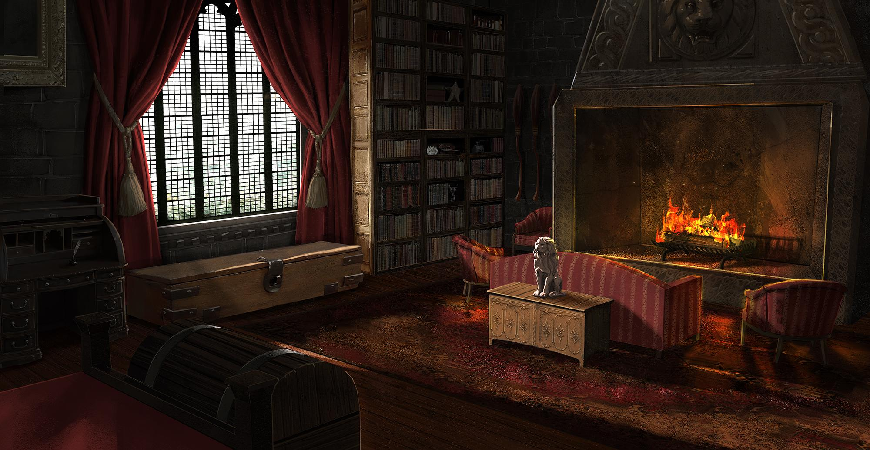

## 

## FORBIDDEN FOREST

The Forbidden Forest, also known as the Dark Forest is located near the Hogwarts School. Trespassing the area is prohibited for students because the forest contains various dangerous creatures. The forest is full of trees and is difficult to cross, especially at night. The heart of the forest is home to many spiders, including large ones, even Acromantulas, a giant magical species of spider.

## 

## TOURNAMENT CAMP

The tournament camp is an agglomeration of tents located outside of Hogwarts, where Triwizard Tournament participants can rest and socialize before participating in the trials. Each challenger is assigned his own personal tent, where he can sleep and leave his personal belongings. At the center of the camp there is a large shed where the wizards gather before the challenge and where they celebrate the end of the trials.

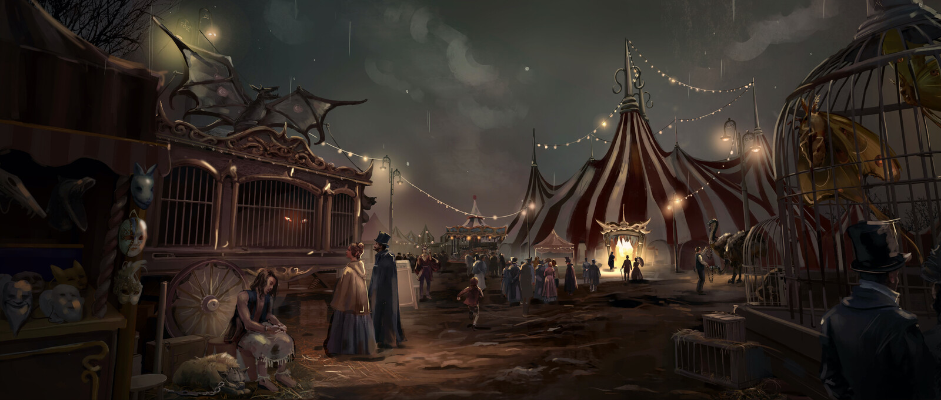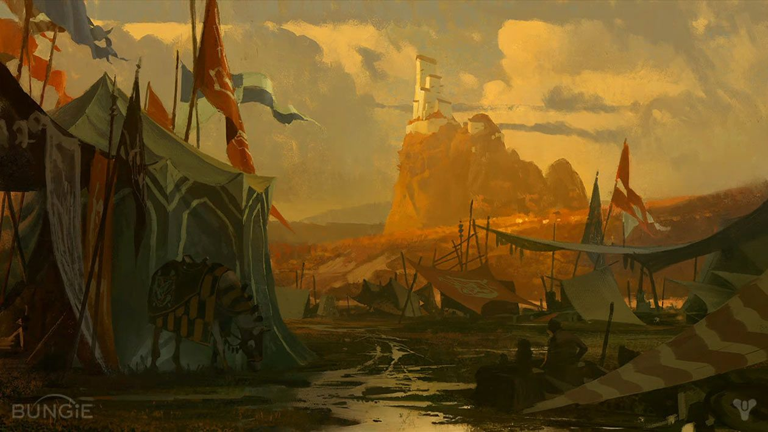

## 

## TRIWIZARD ARENA

In the arena the challengers participate in the three trials of the tournament, thanks to magic it is possible to change the shape of the arena to accommodate the different challenges.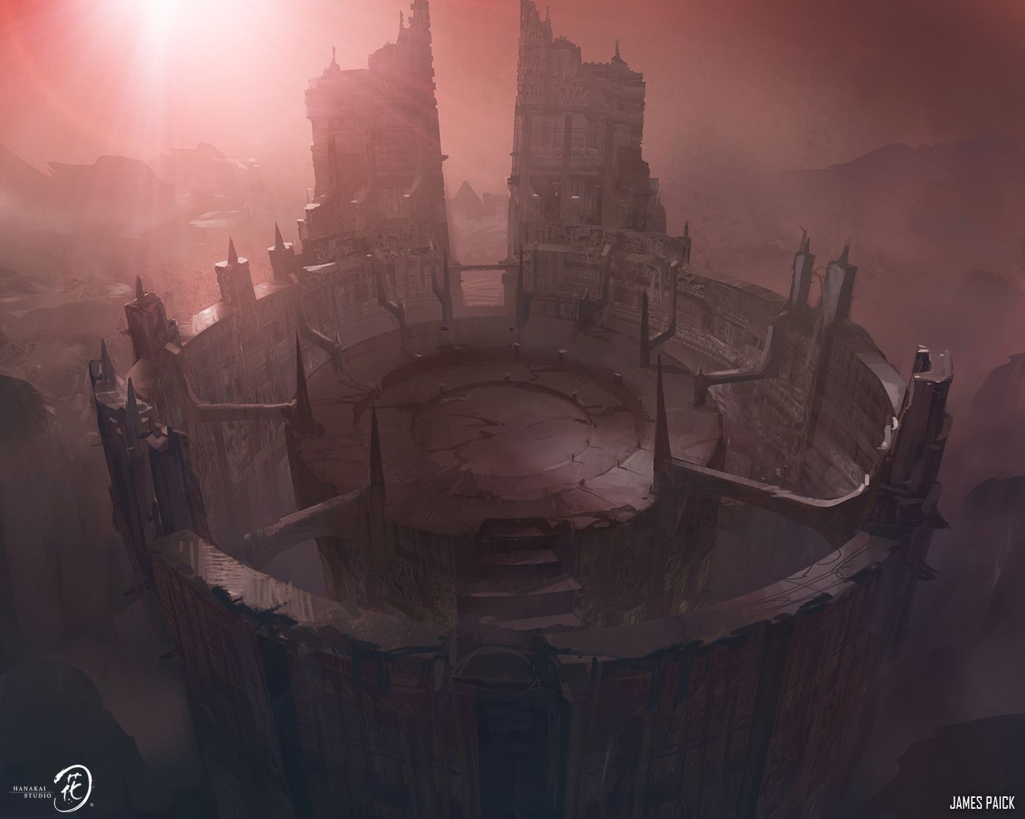

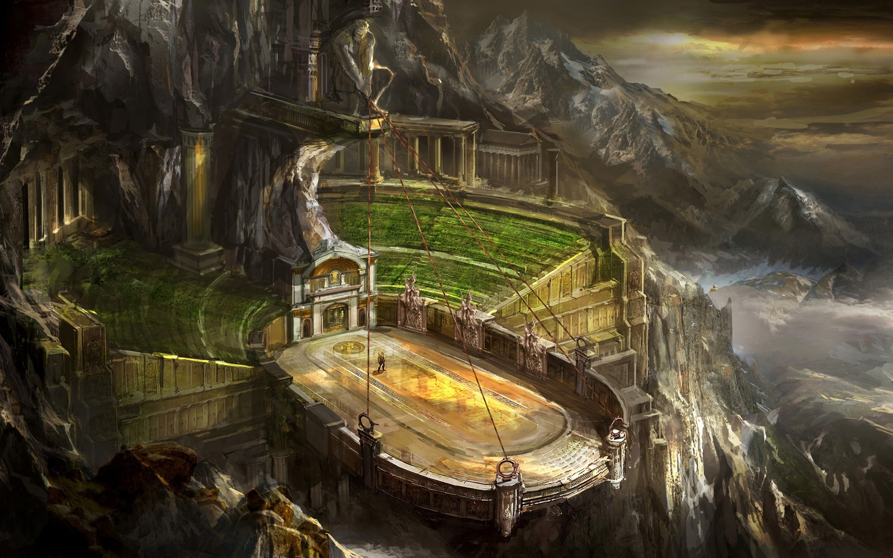

## 

## 

## 

## 

## 

## 

## 

## 

## 

## 

## 

## 

## 

## 

## NOTT’S HIDEOUT

Outside the borders of Hogwarts, hidden in the mountains, is the cave used as a hideout by Nott the Death Eater. The cave is protected by magical creatures. The hiding place contains Nott's personal belongings that show his real identity.

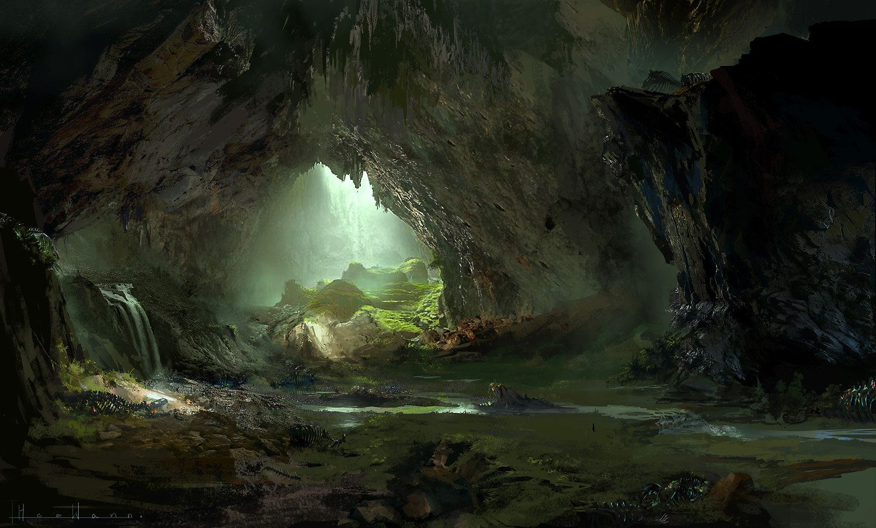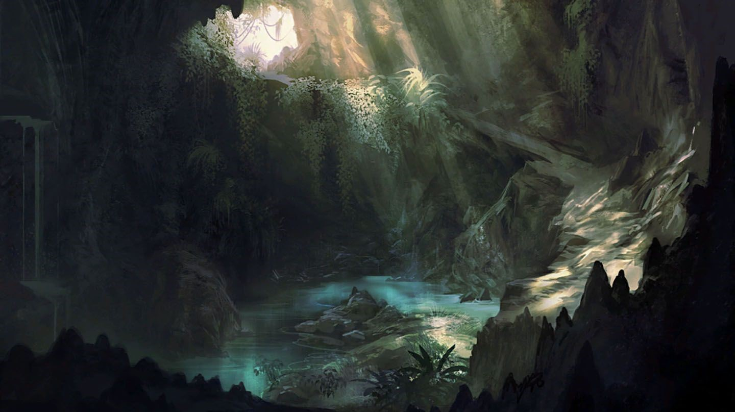

# 

# 

# 

# 

# 

# 

# 

# 

# SYNOPSIS

# 

## ACT 1

The story begins in Diagon Alley, with a young Minerva McGonagall looking for her magician's needs to bring to Hogwarts. After meeting an older wizard, Nott, the two go together on track 9 ¾ and go to Hogwarts. Minerva starts taking lessons and immediately demonstrates her skills. But after she was not chosen for the transfiguration club, she starts to lose faith in Dumbledore and starts to improve herself, also with the help of Nott, and on his advice she comes to the decision to join the Triwizard Tournament to get the Felix Felicis.

## ACT 2

The goblet chosen Minerva, a first-year student, to represent Hogwarts, this event amazes all the school and the participants. Minerva overcomes the three challenges, the “Beast challenge”, the “Chimaera’s dungeon” and the “Free for all”, demonstrating her power to all, and winning the Felix Felicis.

## ACT 3

After a confrontation with Dumbledore, where he tells her about a bad omen and to pay attention to people she trusts, she decides to follow Nott and find out more about him. After discovering his hideout, Nott tries to convince her to follow his plan to defeat Dumbledore.

## ACT 3.1: Minerva wants to protect Dumbledore

Minerva pretends to accept Nott's proposal and goes to tell Dumbledore everything, then she takes the Felix Felicis and together goes to Nott's hideout. Nott tries to go back in time but his time turner breaks and after an epic battle, Minerva defeats Nott.

## ACT 3.2: Minerva wants to follow Nott's plan

Minerva, full of rage against Dumbledore, takes the Felix Felicis to sneak into Dumbledore's office and takes him to the hideout with a portkey. After an epic battle, Minerva defeats Dumbledore.

# 

# 

# 

# 

# 

# 

# 

# 

# STORY PLOT

# 

The story begins with Minerva coming out of the leaky cauldron and seeing Diagon Alley for the first time. Our protagonist begins to go around the various stores to buy everything you need to start attending Hogwarts, including books, uniform and finally the wand. As soon as she leaves Olivander, Minerva notices that something is wrong at the Gambol and Japes Wizarding Joke Shop, where some magical toys have started to go crazy. The situation returns to normal thanks to the help of Nott, an older boy who immediately empathizes with Minerva and together they head to track 9 3/4 to reach Hogwarts. After a long sorting ceremony Minerva goes to the common room to prepare for the next day's classes, including potions, transfiguration and spells. In the following months Minerva shows particular talent especially in transfiguration, but Professor Dumbledore still considers her too immature to be a member of his club, causing doubts in the young Minerva, who spends more and more time with Theodore who offers to help her even in ways not allowed in the school. One night Theodore convinces Minerva to follow him into the forbidden forest to look for special ingredients, but after failing to do so, Theodore confesses to Minerva that he needs Felix Felicis, telling to her a lie about what the potion is for. Nott's request together with the desire to demonstrate his skills led her to the decision to enter the Triwizard Tournament. Minerva is chosen as a champion for Hogwarts, this causes dislike towards her by the other participants, as well as perplexity about her young age. This provokes in her the desire to demonstrate her abilities to everyone. The tournament begins and Minerva is about to start the first test, in which she must be able to recover a crystal ball defended by a basilisk inside the arena. The next challenge is to pass a dungeon where Minerva's intelligence is put to the test. Finally, in the last challenge where the goal is to bring the cup to the predetermined point after one of the three wizards is out of combat, Minerva manages to steal it after a grueling chase and thus win the tournament. After the evening of celebration, in which Theodore seems to have disappeared, Minerva is summoned by Dumbledore, who warns her that she perceived something obscure that might have made her win during the tournament, stressing that she does not trust anyone. A few days later Minerva sees Theodore and after following him to his hiding place she is confronted with a difficult decision, believe Nott and fight against Dumbledore, or report everything to Dumbledore to stop Theodore?

# 

# 

# MAIN STORYTELLING ELEMENTS

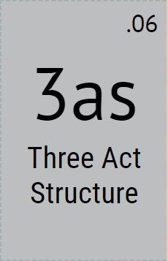

The story follows a three act structure, with the first act focused on setup statistics and stuff at Diagon Alley, the second one shows the efforts of Minerva to overcome the challenges of the tournament, and in the final act the story ends with an epic fight that brings to completion the choices made previously.



The reveal of Theodore in the last chapter is the trigger that takes Minerva to choose in the end between Theodore and Dumbledore and to fight against one of them.

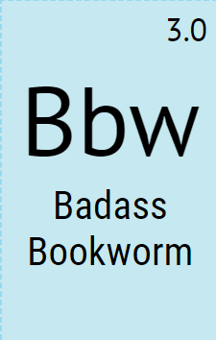

Minerva is a badass bookworm hero, quiet and smart, but with unexpected formidable physical and practical skills.

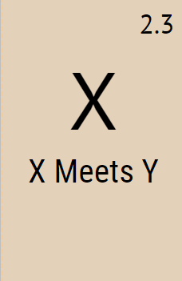

A fundamental moment is the meeting between Minerva and Theodore ‘cause is the first event that changes the timeline and all the consequences start by this moment.

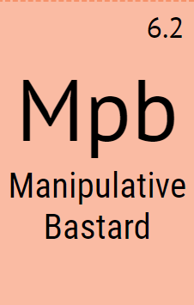

Theodore Nott is a manipulative bastard, a character who manipulates others, in this case Minerva, through their emotions, perspectives, psychologies.

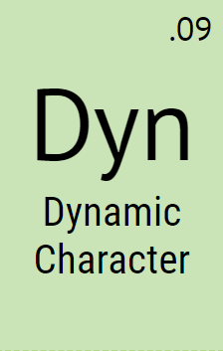

Minerva changes character through the story depending on what she has chosen before, that modified his relationship between the other character and also his personal purpose.

# 

# 

# 

# 

# 

# 

# STORY FLOWCHART

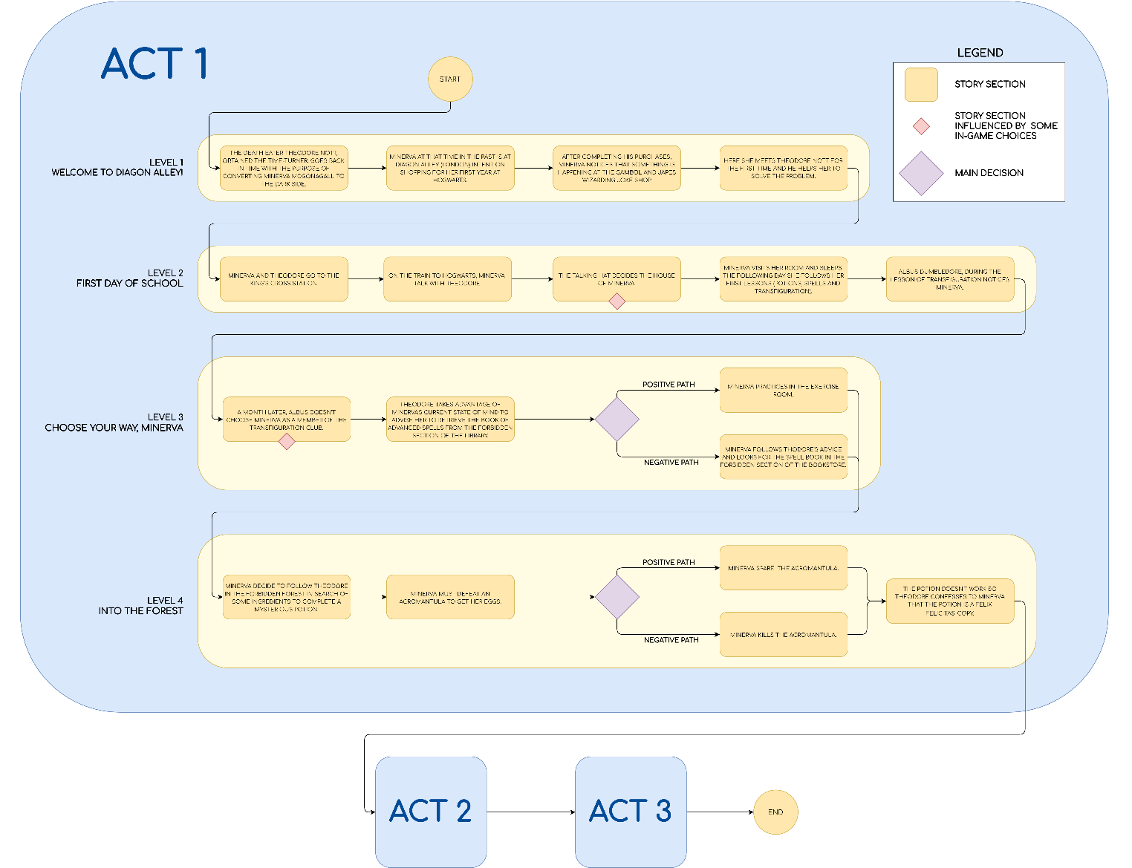

# 

# 

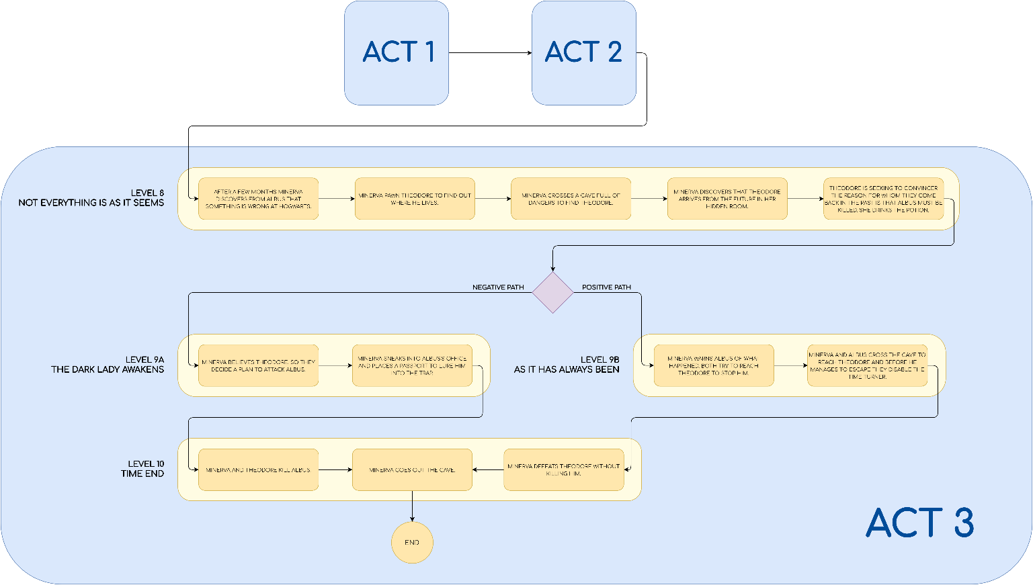

# 

# 

# 

# 

# THEMES

**Trust**: The main theme of the story concerns the importance of the choices that are made and their impact on the relationships of trust between people.

In the game Minerva takes choices that influence herself and her relationships, sometimes in a good way, sometimes in others...

**Honour**: The desire to stand out for our commitment, which in a world where nothing is as it seems can lead to madness...

Minerva is a young woman with a strong sense of honor, for her being the best student is the most important thing during her studies at Hogwarts, and for her purpose she would do anything.

**The difficulty of distinguishing good from evil**: Everything always depends on the point of view and also on the knowledge/absence of information.

Through the game Minerva has to decide which way to choose based mainly on the information received from her Transfiguration professor, Dumbledore, and her new "friend" Nott.

# 

# 

# 

# 

# 

# 

# 

# CHARACTERS

## 

## MINERVA MCGONAGALL

### 

### DESCRIPTION

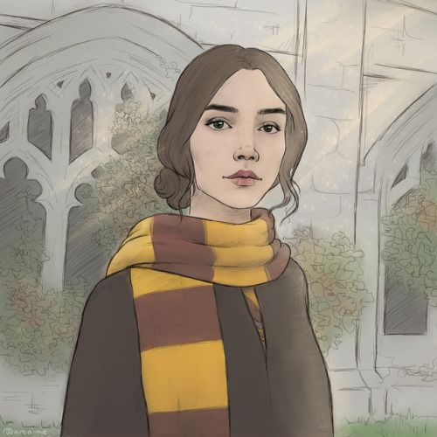

Minerva is a young witch born in a family of half-blood. Living with Muggles she always had to hide her nature until the day she received the admittance letter from Hogwarts School where she will be able to exercise her talents. She has a vocation for study and excels in everything she does, is enterprising and courageous and does not stop in the face of obstacles. Her moral compass is not yet well defined and this leads her into trouble.

### 

### CIRCUMPLEX

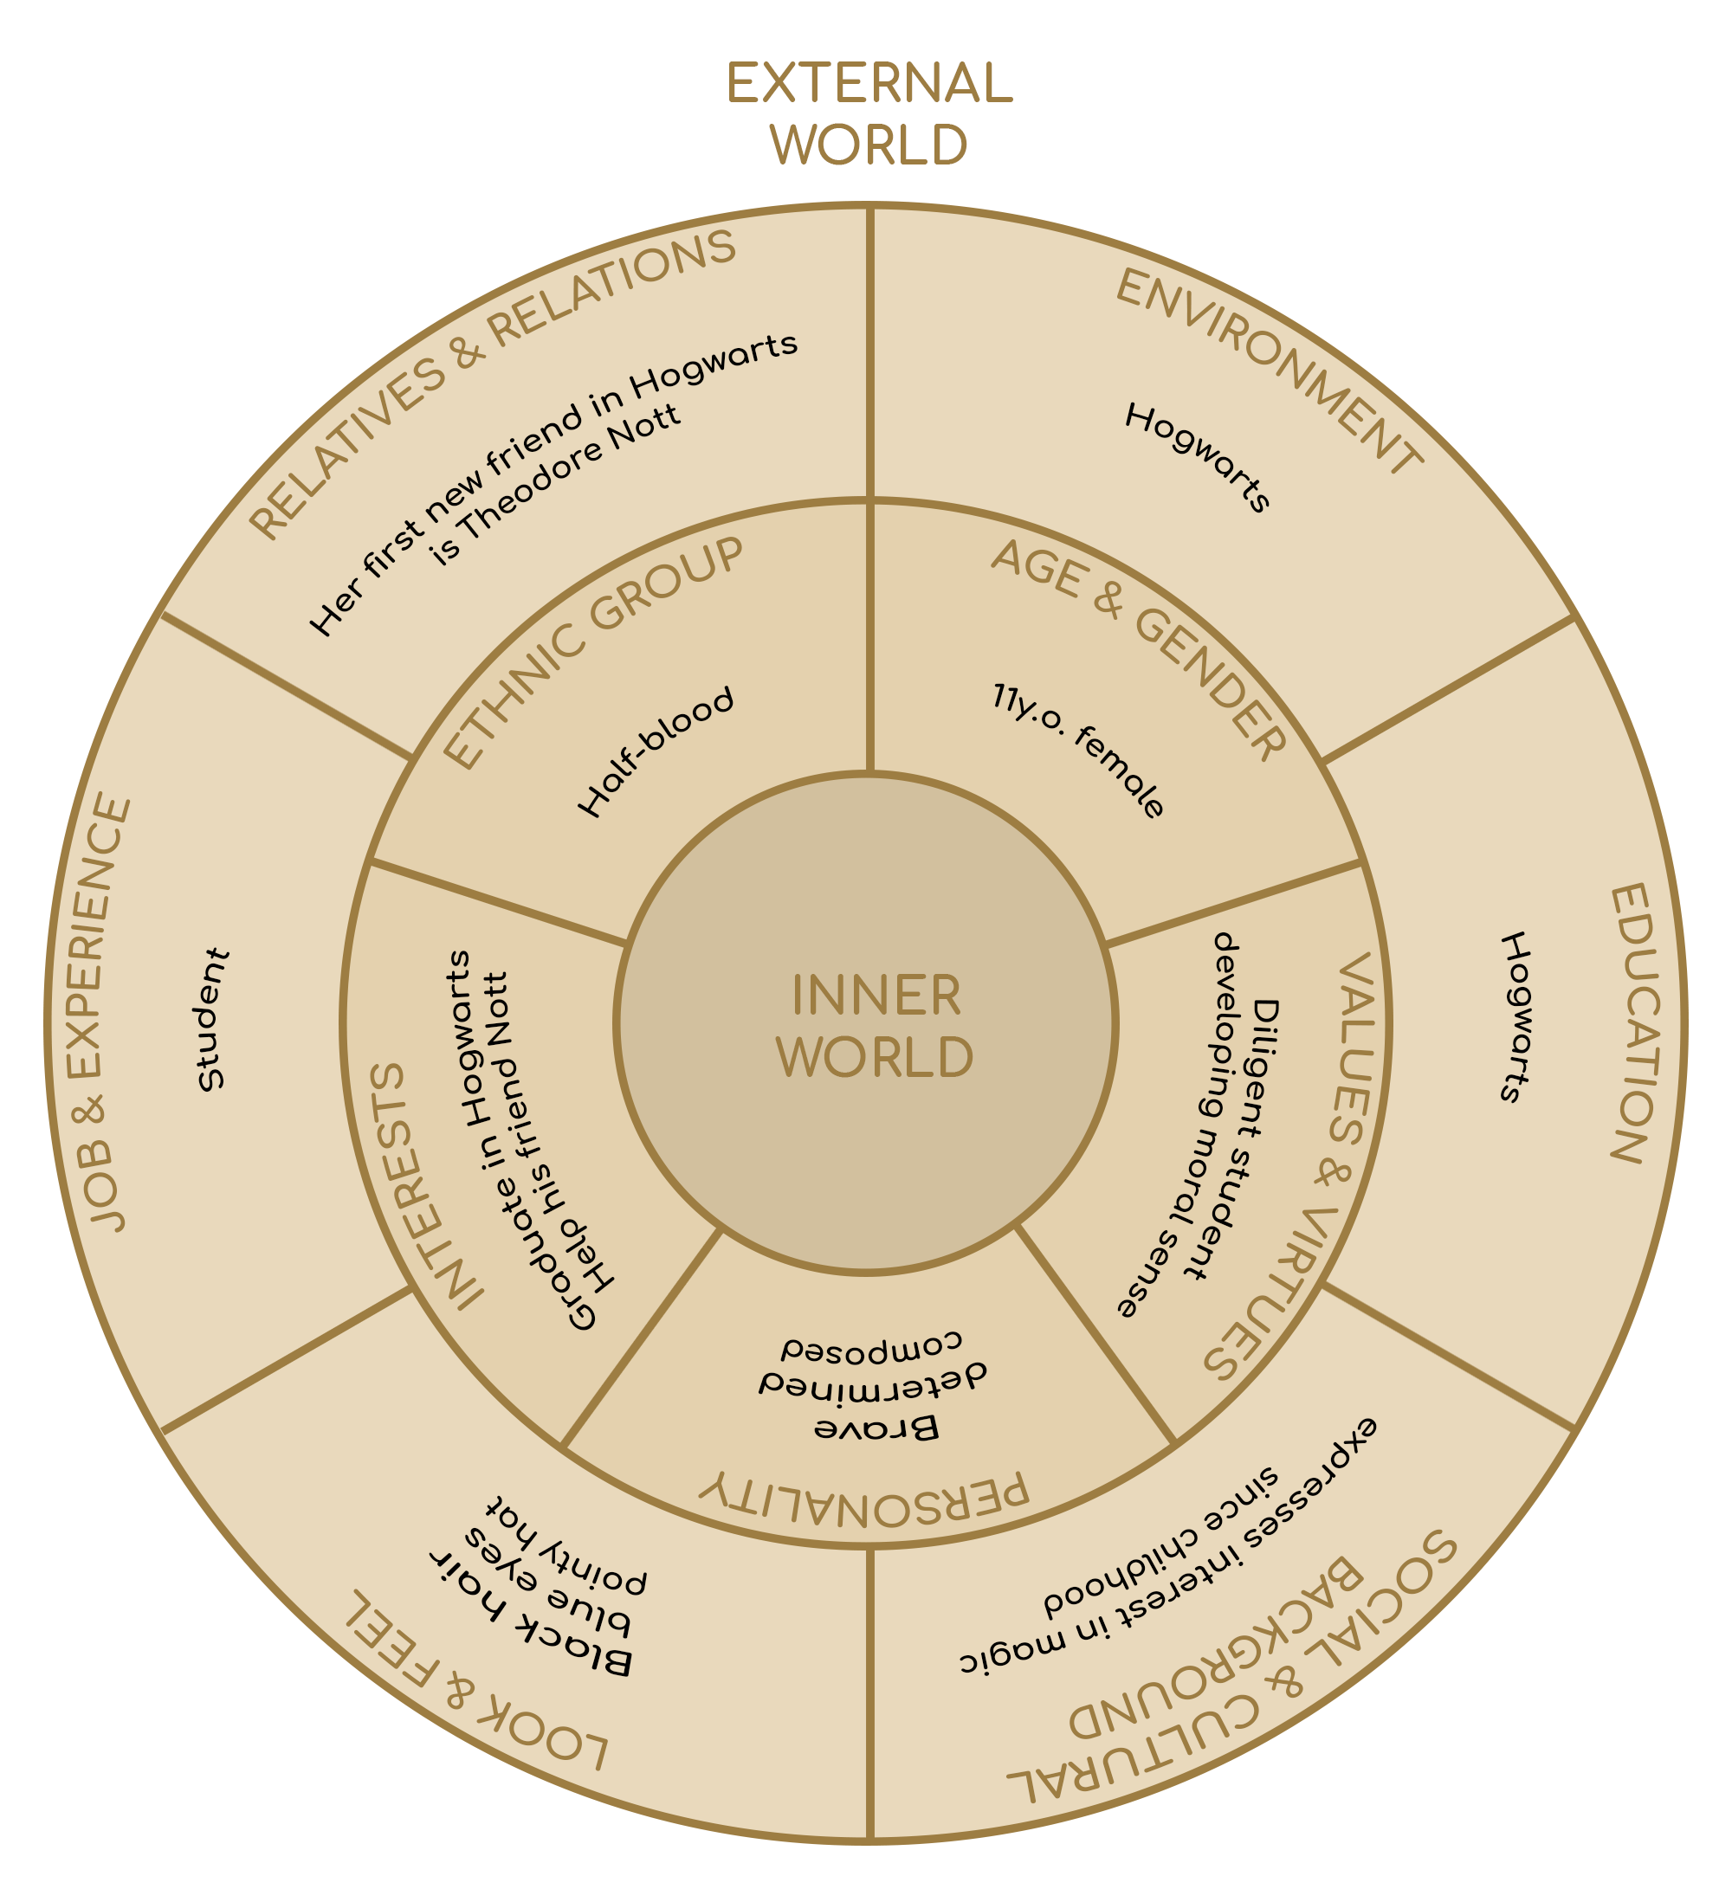

### RELATIONSHIP MAP

ACT 1-2

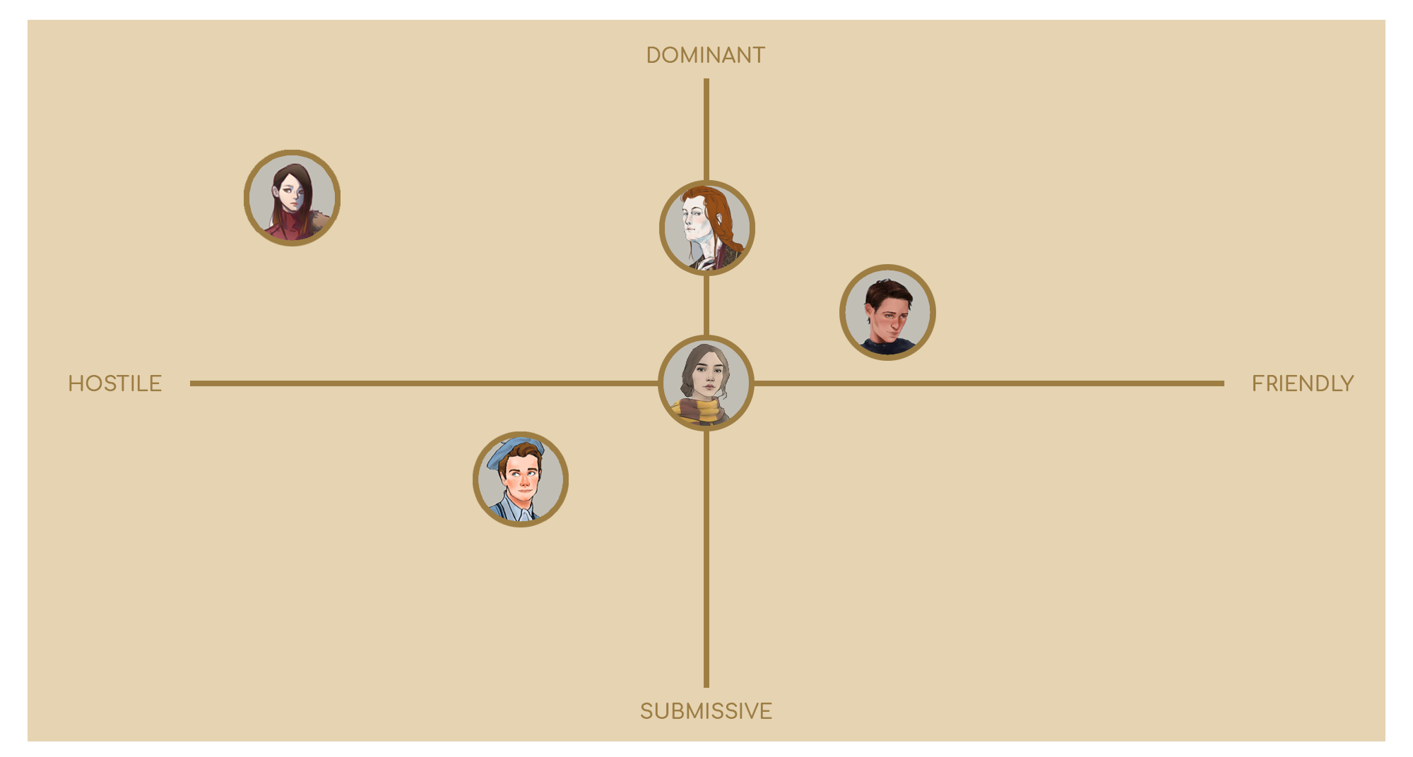

ACT 3.1

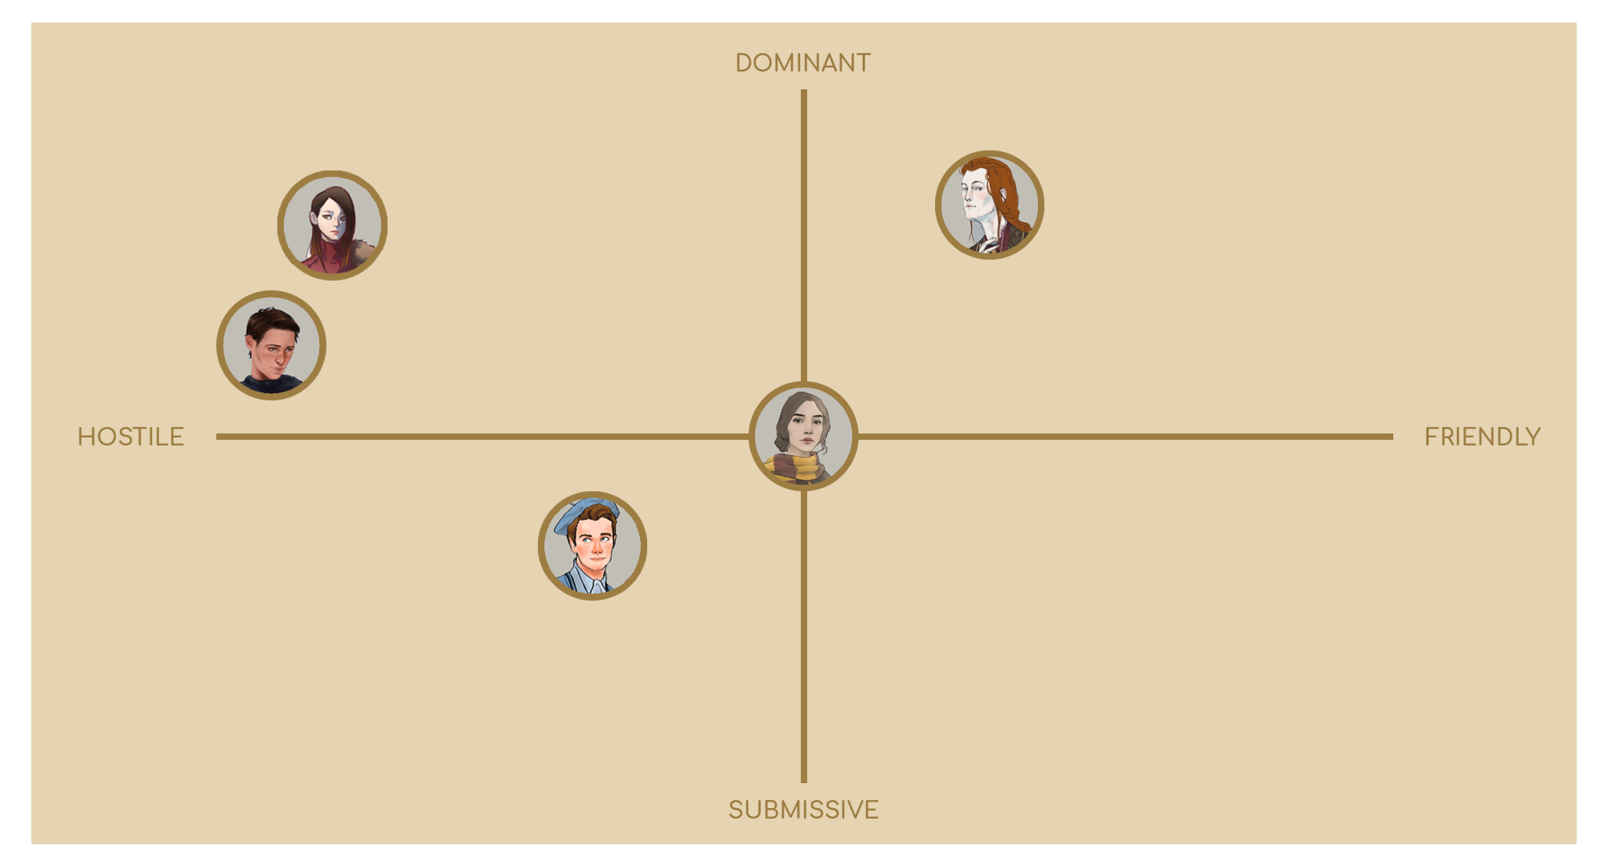

ACT 3.2

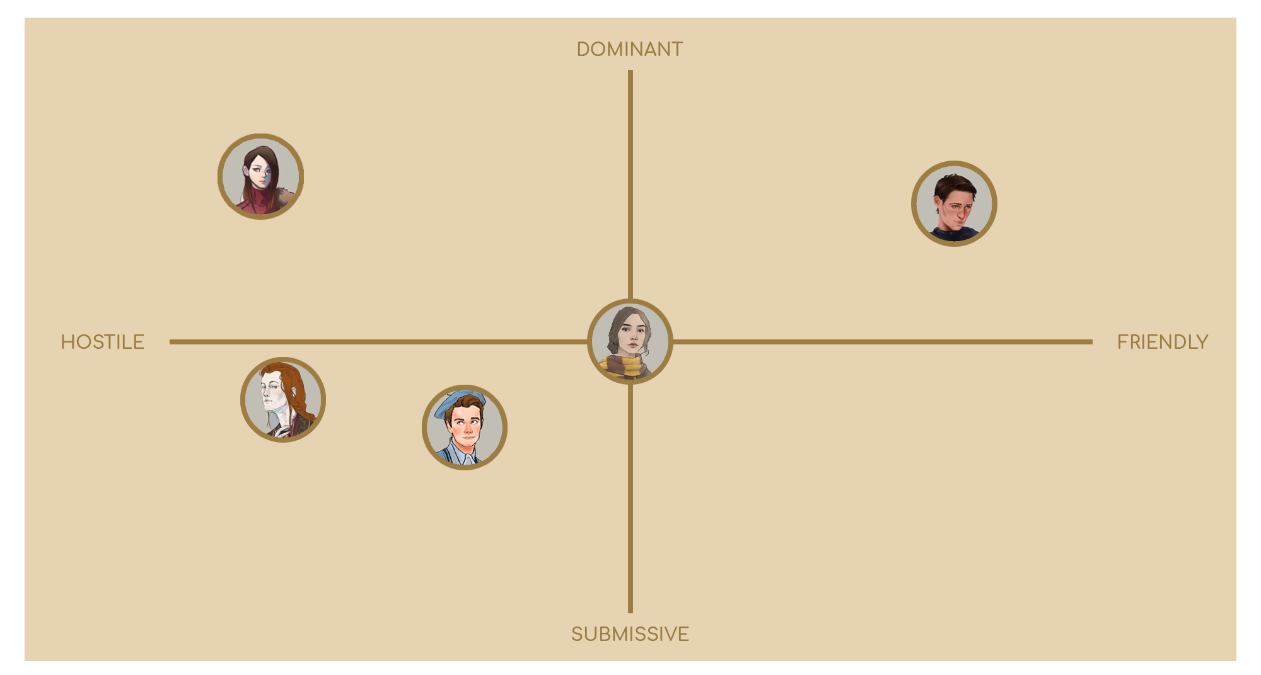

## 

## 

## 

## 

## ALBUS DUMBLEDORE

### 

### DESCRIPTION

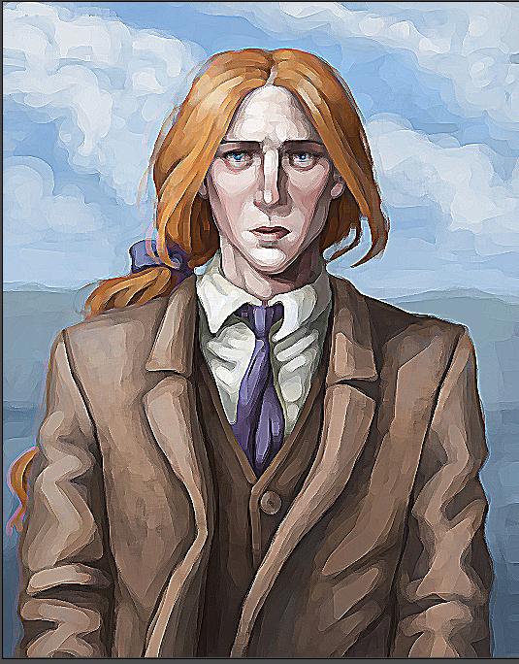

Albus Percival Wulfric Brian Dumbledore is a middle-aged professor who teaches transfiguration at the Hogwarts School of Witchcraft and Wizardry. Albus is a half-blood and shows much less years than he has. His purpose from a young age is to protect the world of wizards from the forces of evil by distinguishing himself by his acumen and dexterity in mastering spells. His passion for transfiguration led him to receive the chair as transfiguration professor. Instructing wizards to use magic for the common good is his primary goal.

### 

### CIRCUMPLEX

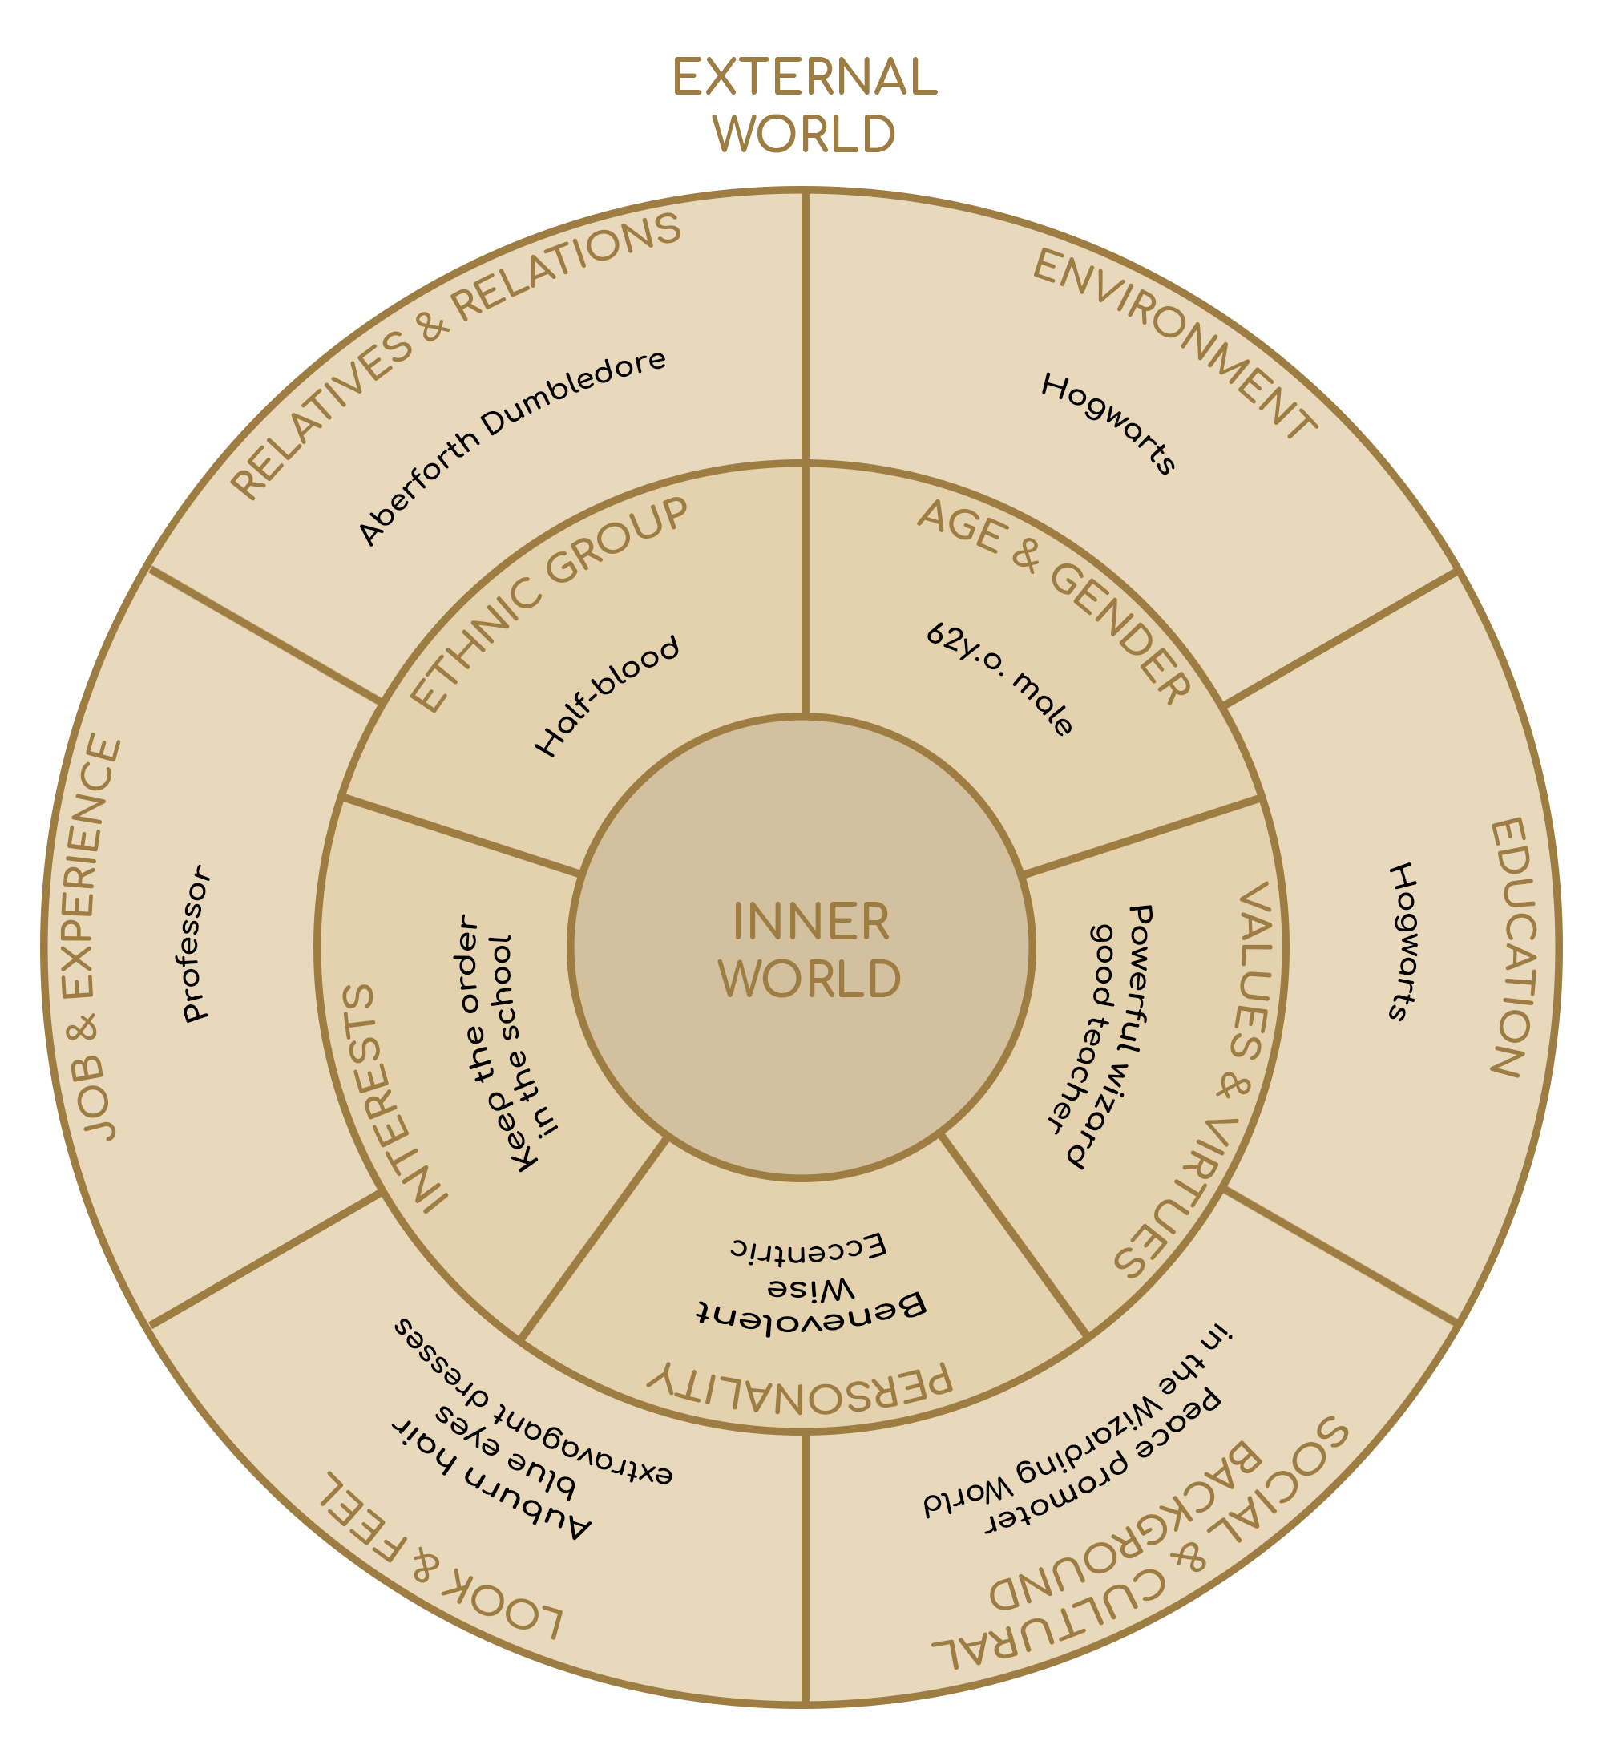

### 

### 

### RELATIONSHIP MAP

ACT 1-2

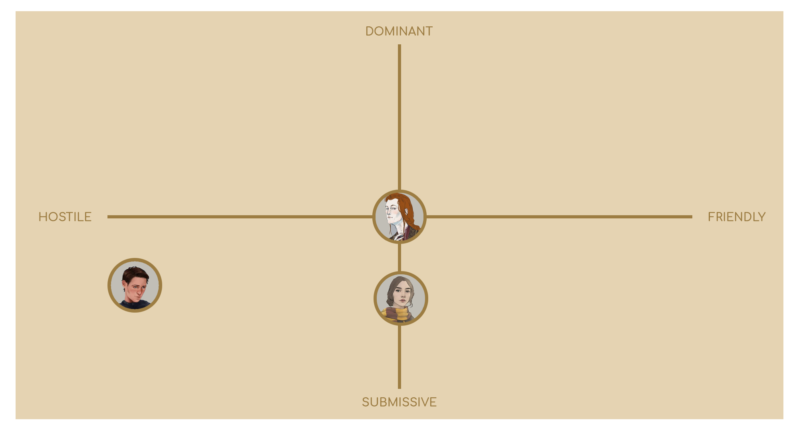

ACT 3.1

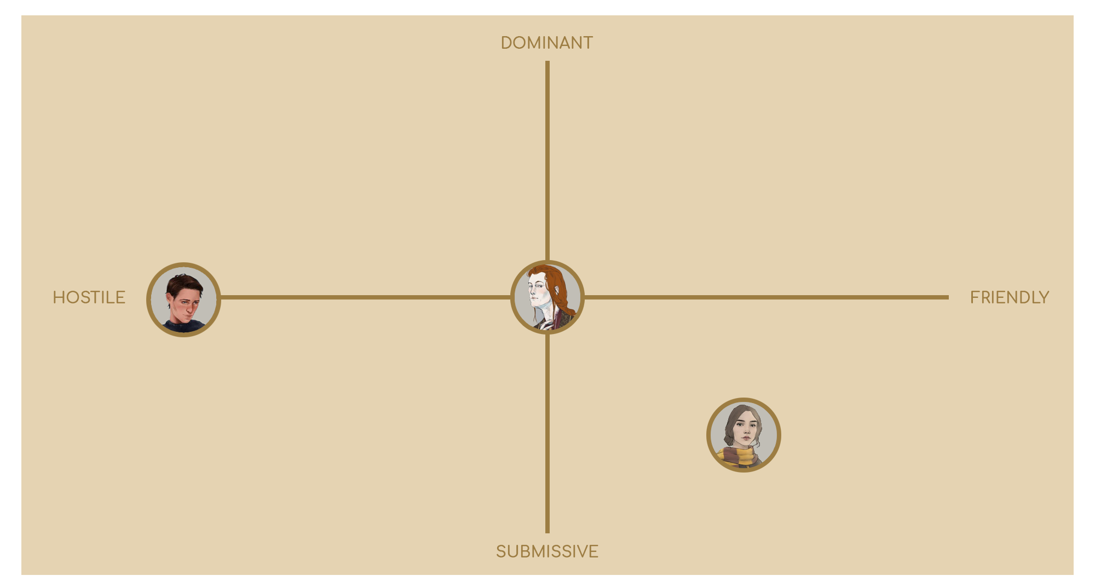

ACT 3.2

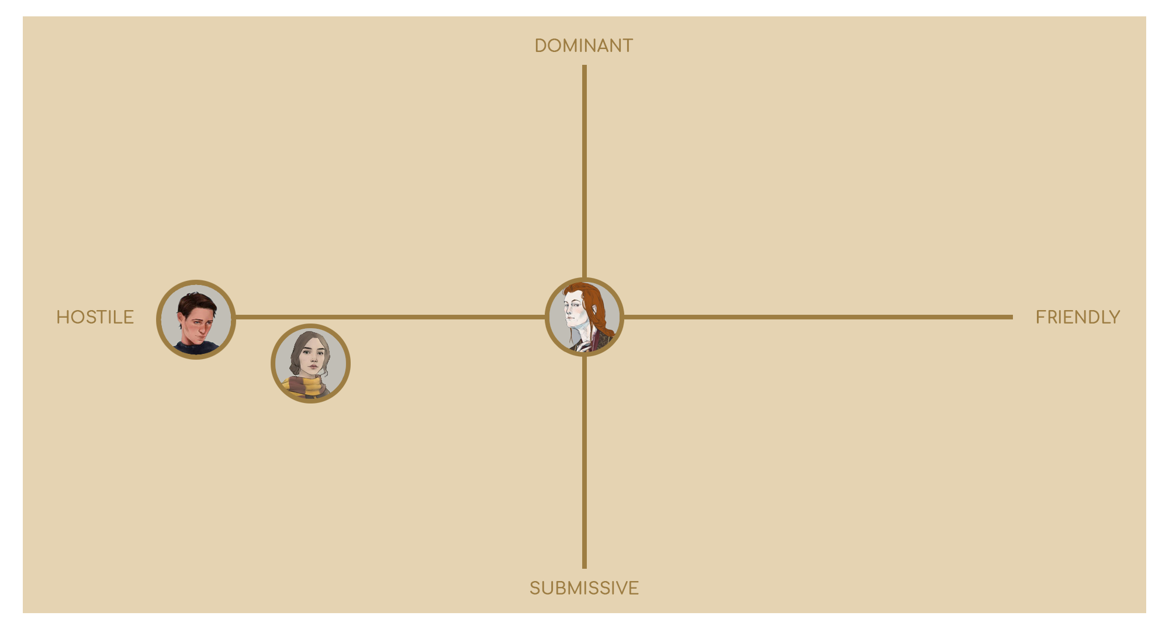

## 

## THEODORE NOTT

### 

### DESCRIPTION

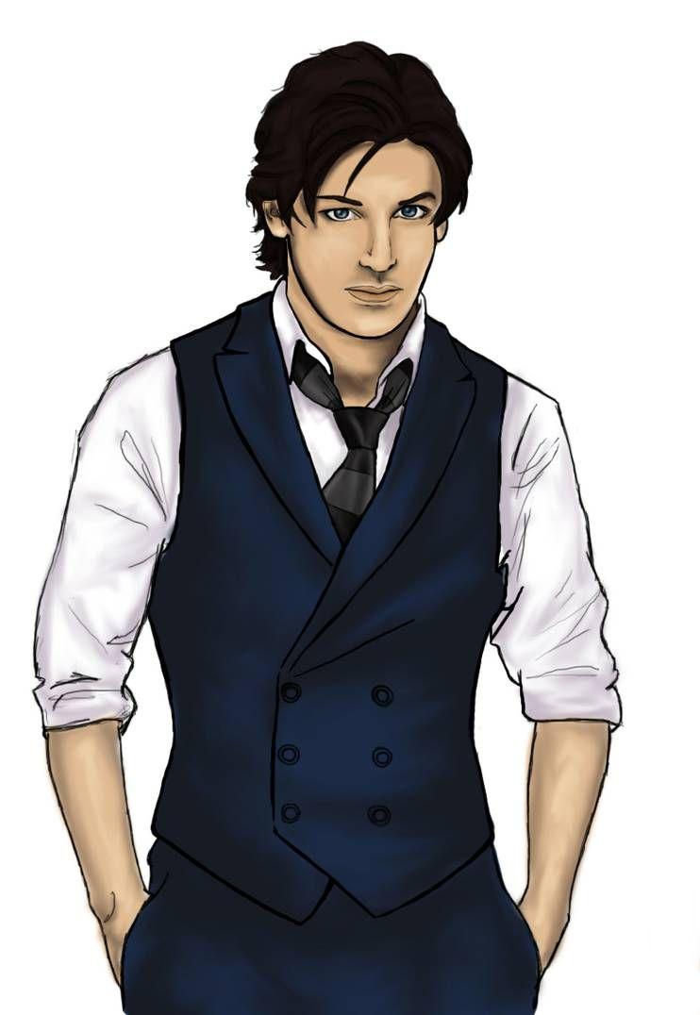

Theodore Nott is a young man grown up in a pure-blood supremacy environment. He has always been a solitary guy, very smart and skilled with spells and potions as well as being an expert in magical devices. After his studies at Hogwarts and the death of Lord Voldemort, he becomes a death-eater like his father. After he has demonstrated his capabilities to older death-eaters, he is entrusted with a crucial mission, come back in time to take a young Minerva McGonagall on his side and to kill Albus Dumbledore.

### 

### 

### CIRCUMPLEX

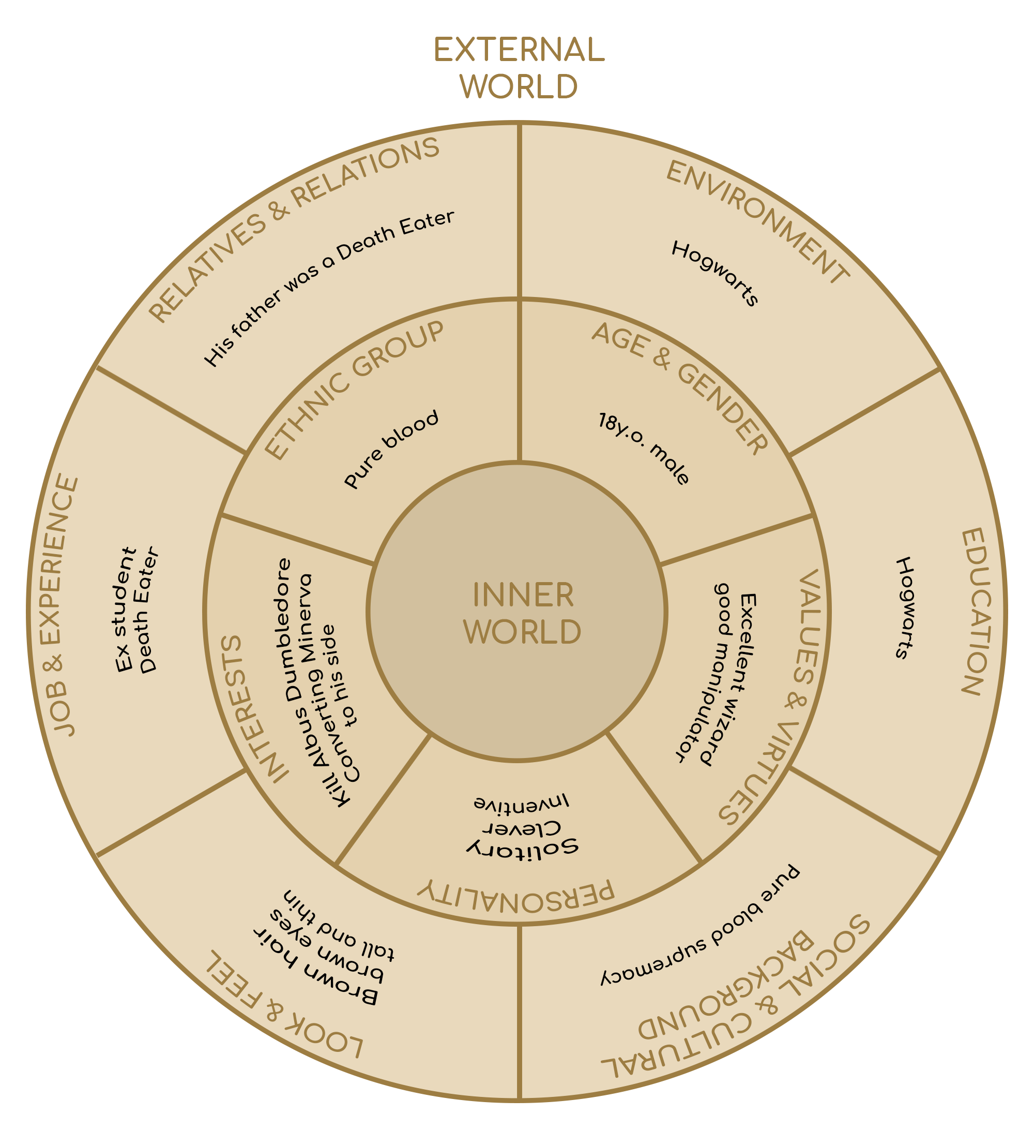

### 

### 

### RELATIONSHIP MAP

**ACT 1-2**

# 

**ACT 3.1**

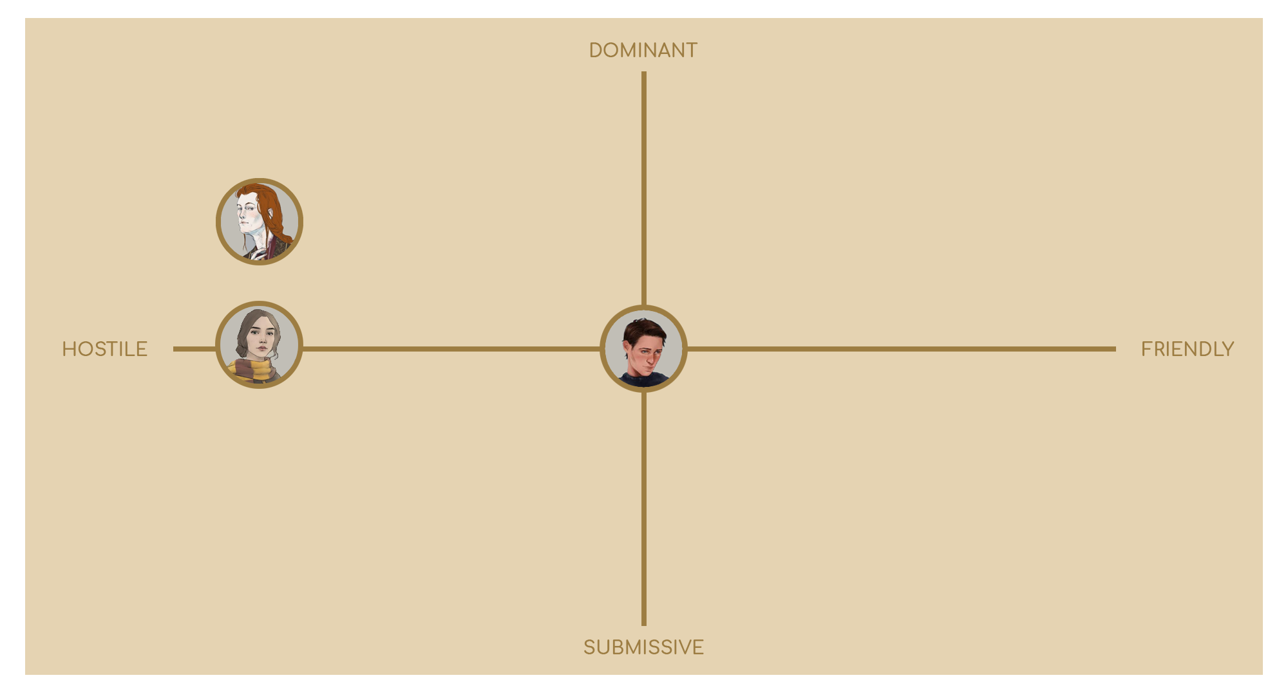

**ACT 3.2**

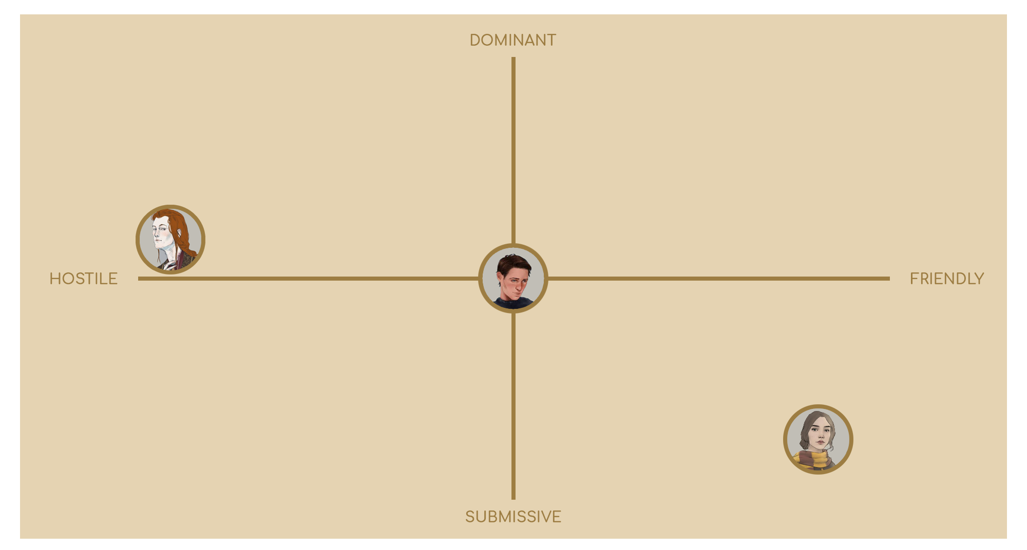

# 

# 

# 

## 

## JACQUES DUGARD

### 

### DESCRIPTION

### 

### 

### 

### 

Jacques Armand Dugard is without doubt the most promising magician of the French school of the Beauxbatons Academy of Magic. He is known throughout the world as the son of Philippe Dugard, the French Minister for Magic. The in-depth study of potions and escapism spells make him a feared challenger of the Triwizard Tournament.

### 

### 

### 

### 

### 

### 

### CIRCUMPLEX

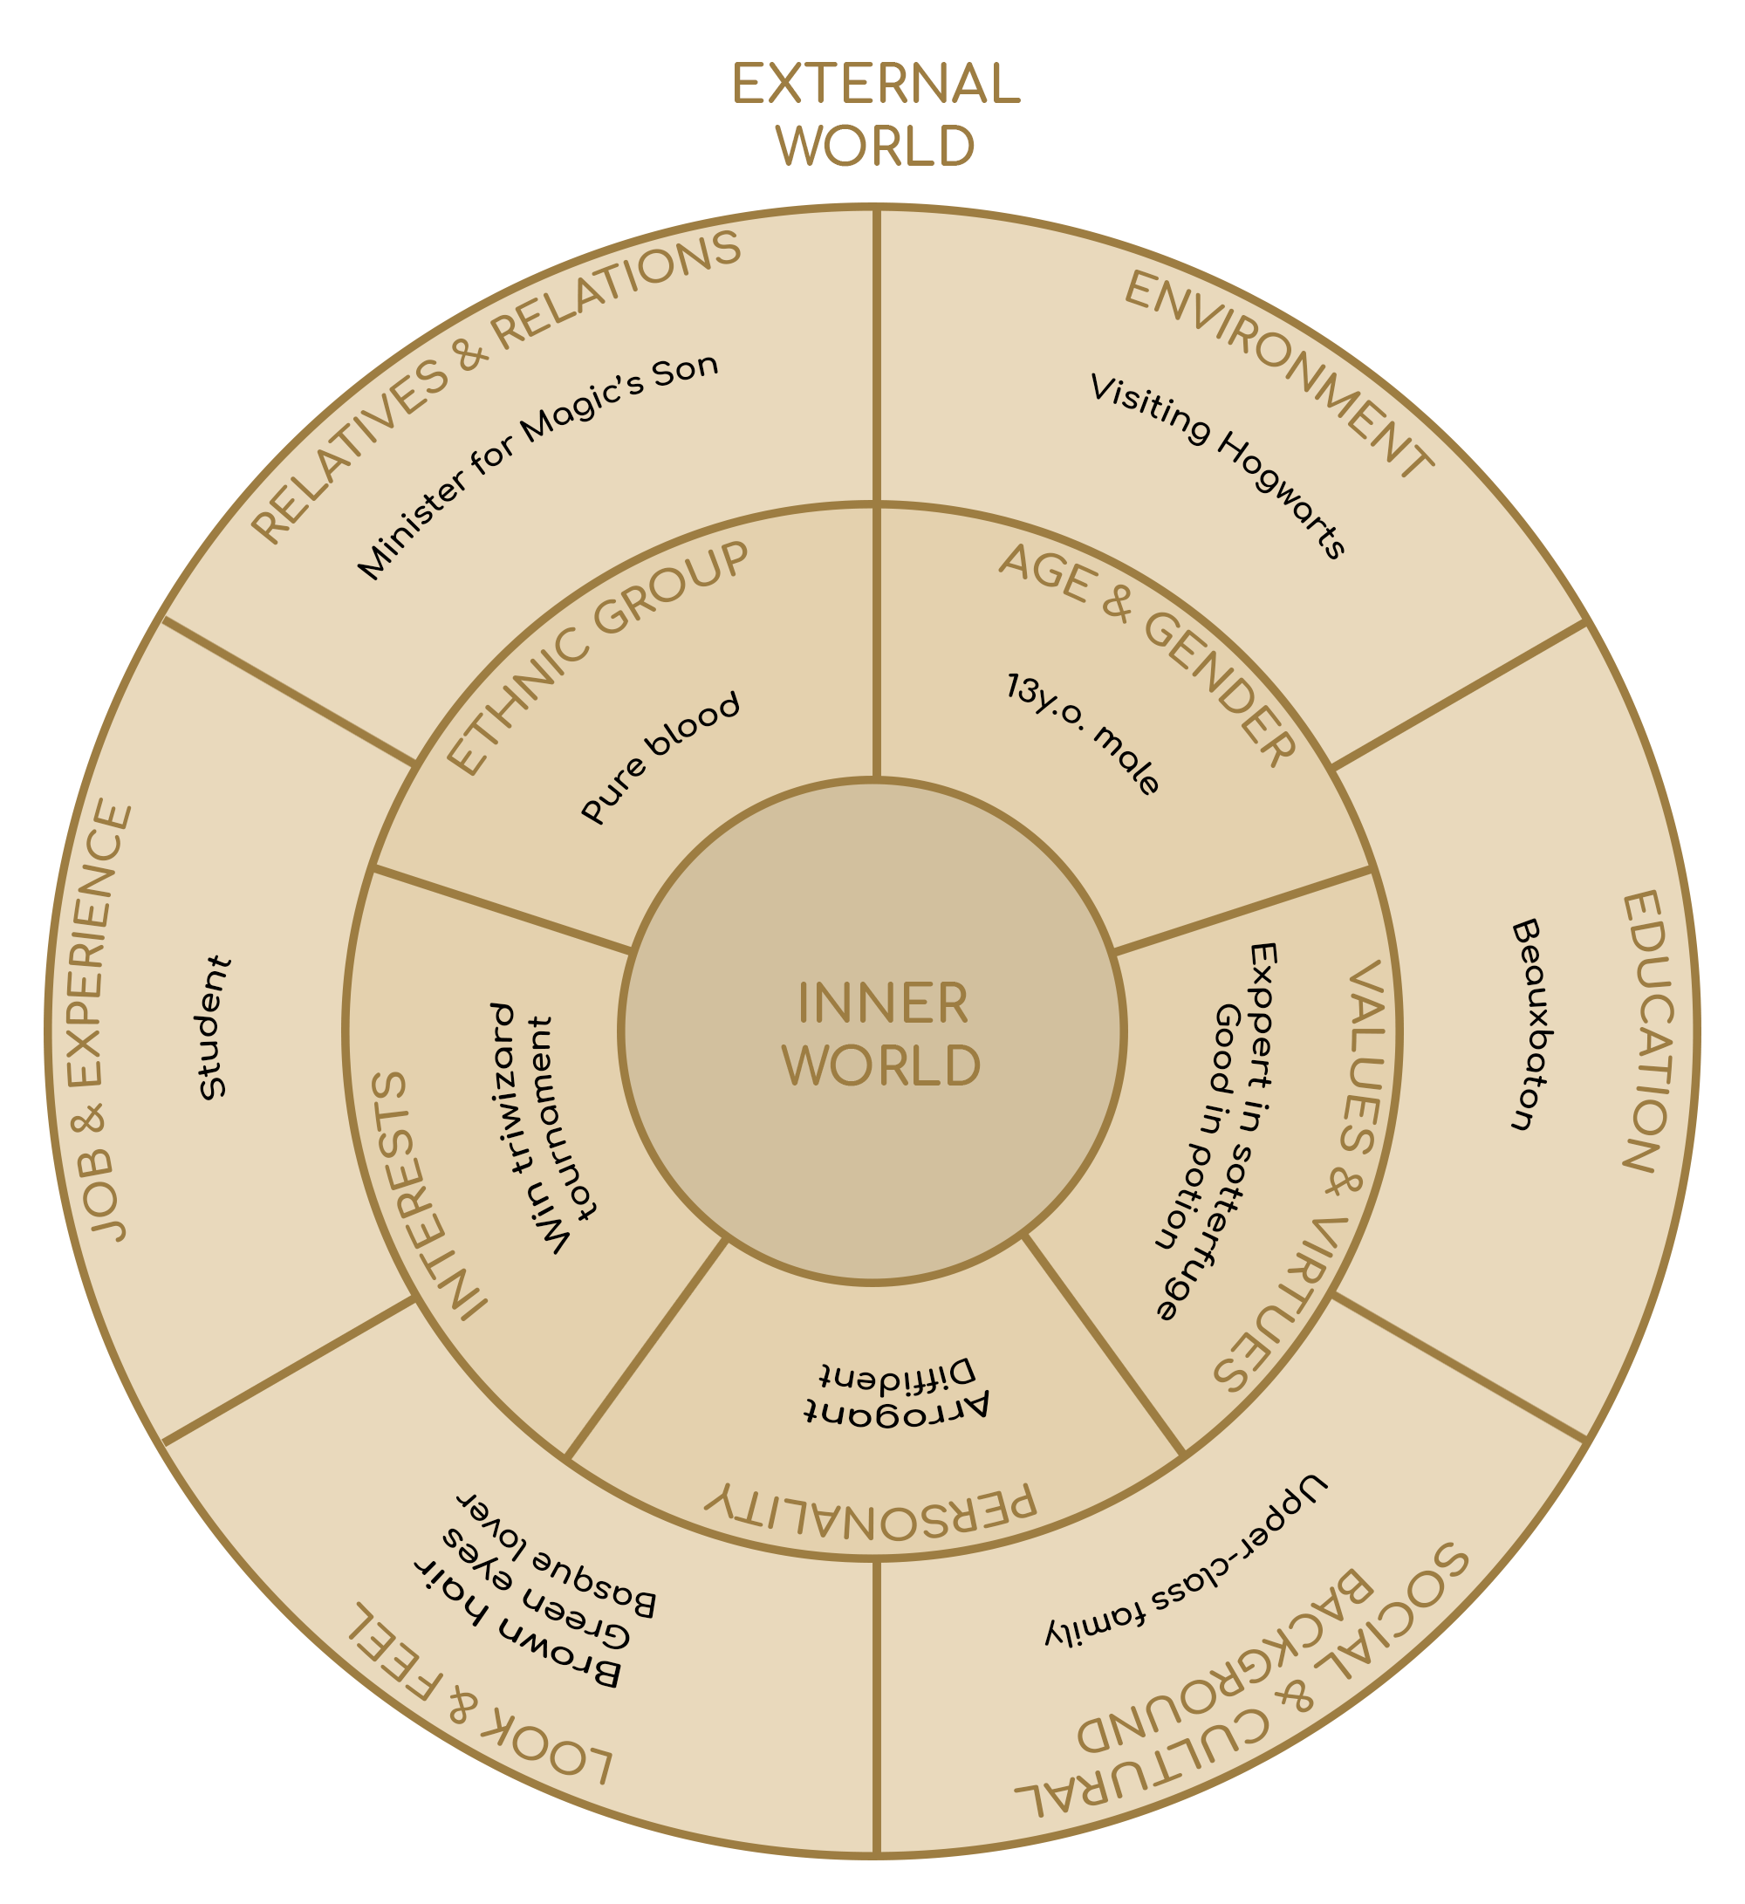

### 

### 

### RELATIONSHIP MAP

**ACT 2**

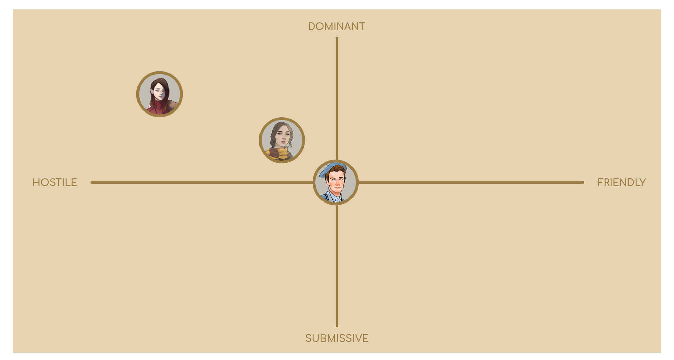

## 

## 

## 

## 

## 

## 

## ASTRID STORMO

### DESCRIPTION

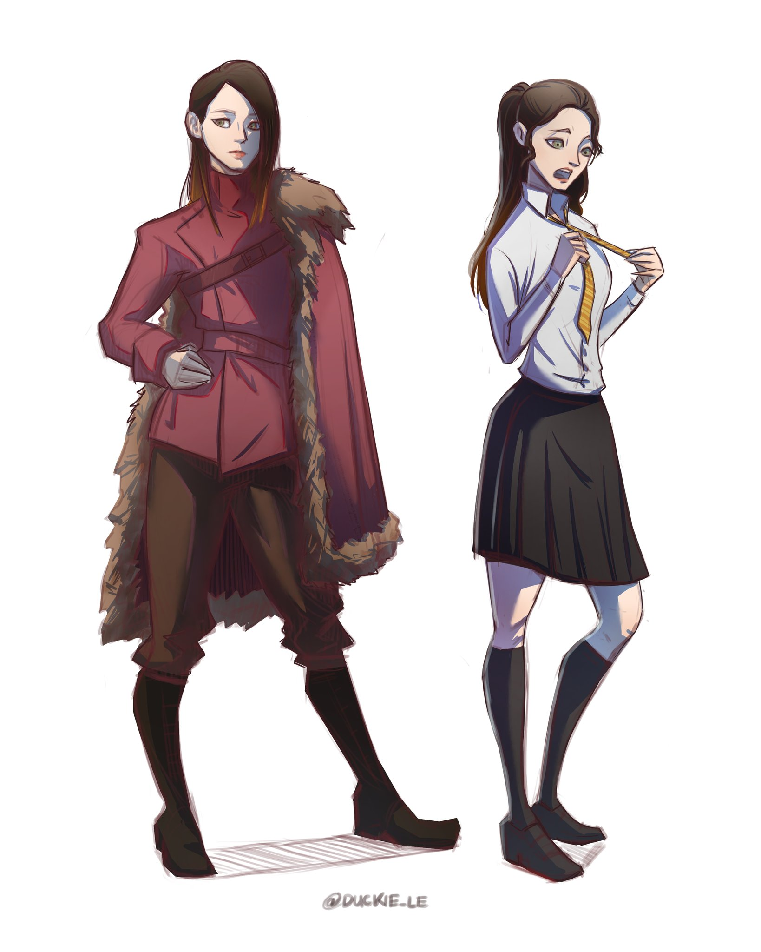

Astrid Stormo is a young woman, there isn’t much information about her like most Durmstrang students. She is a skillful magician, in particular about dark magic. She is aggressive and swagger, and rarely she groups up with her school mates. She is often training near school wearing her inseparable fur, and during his journey at Hogwarts she has only one goal, to win the Triwizard Tournament.

**CIRCUMPLEX**

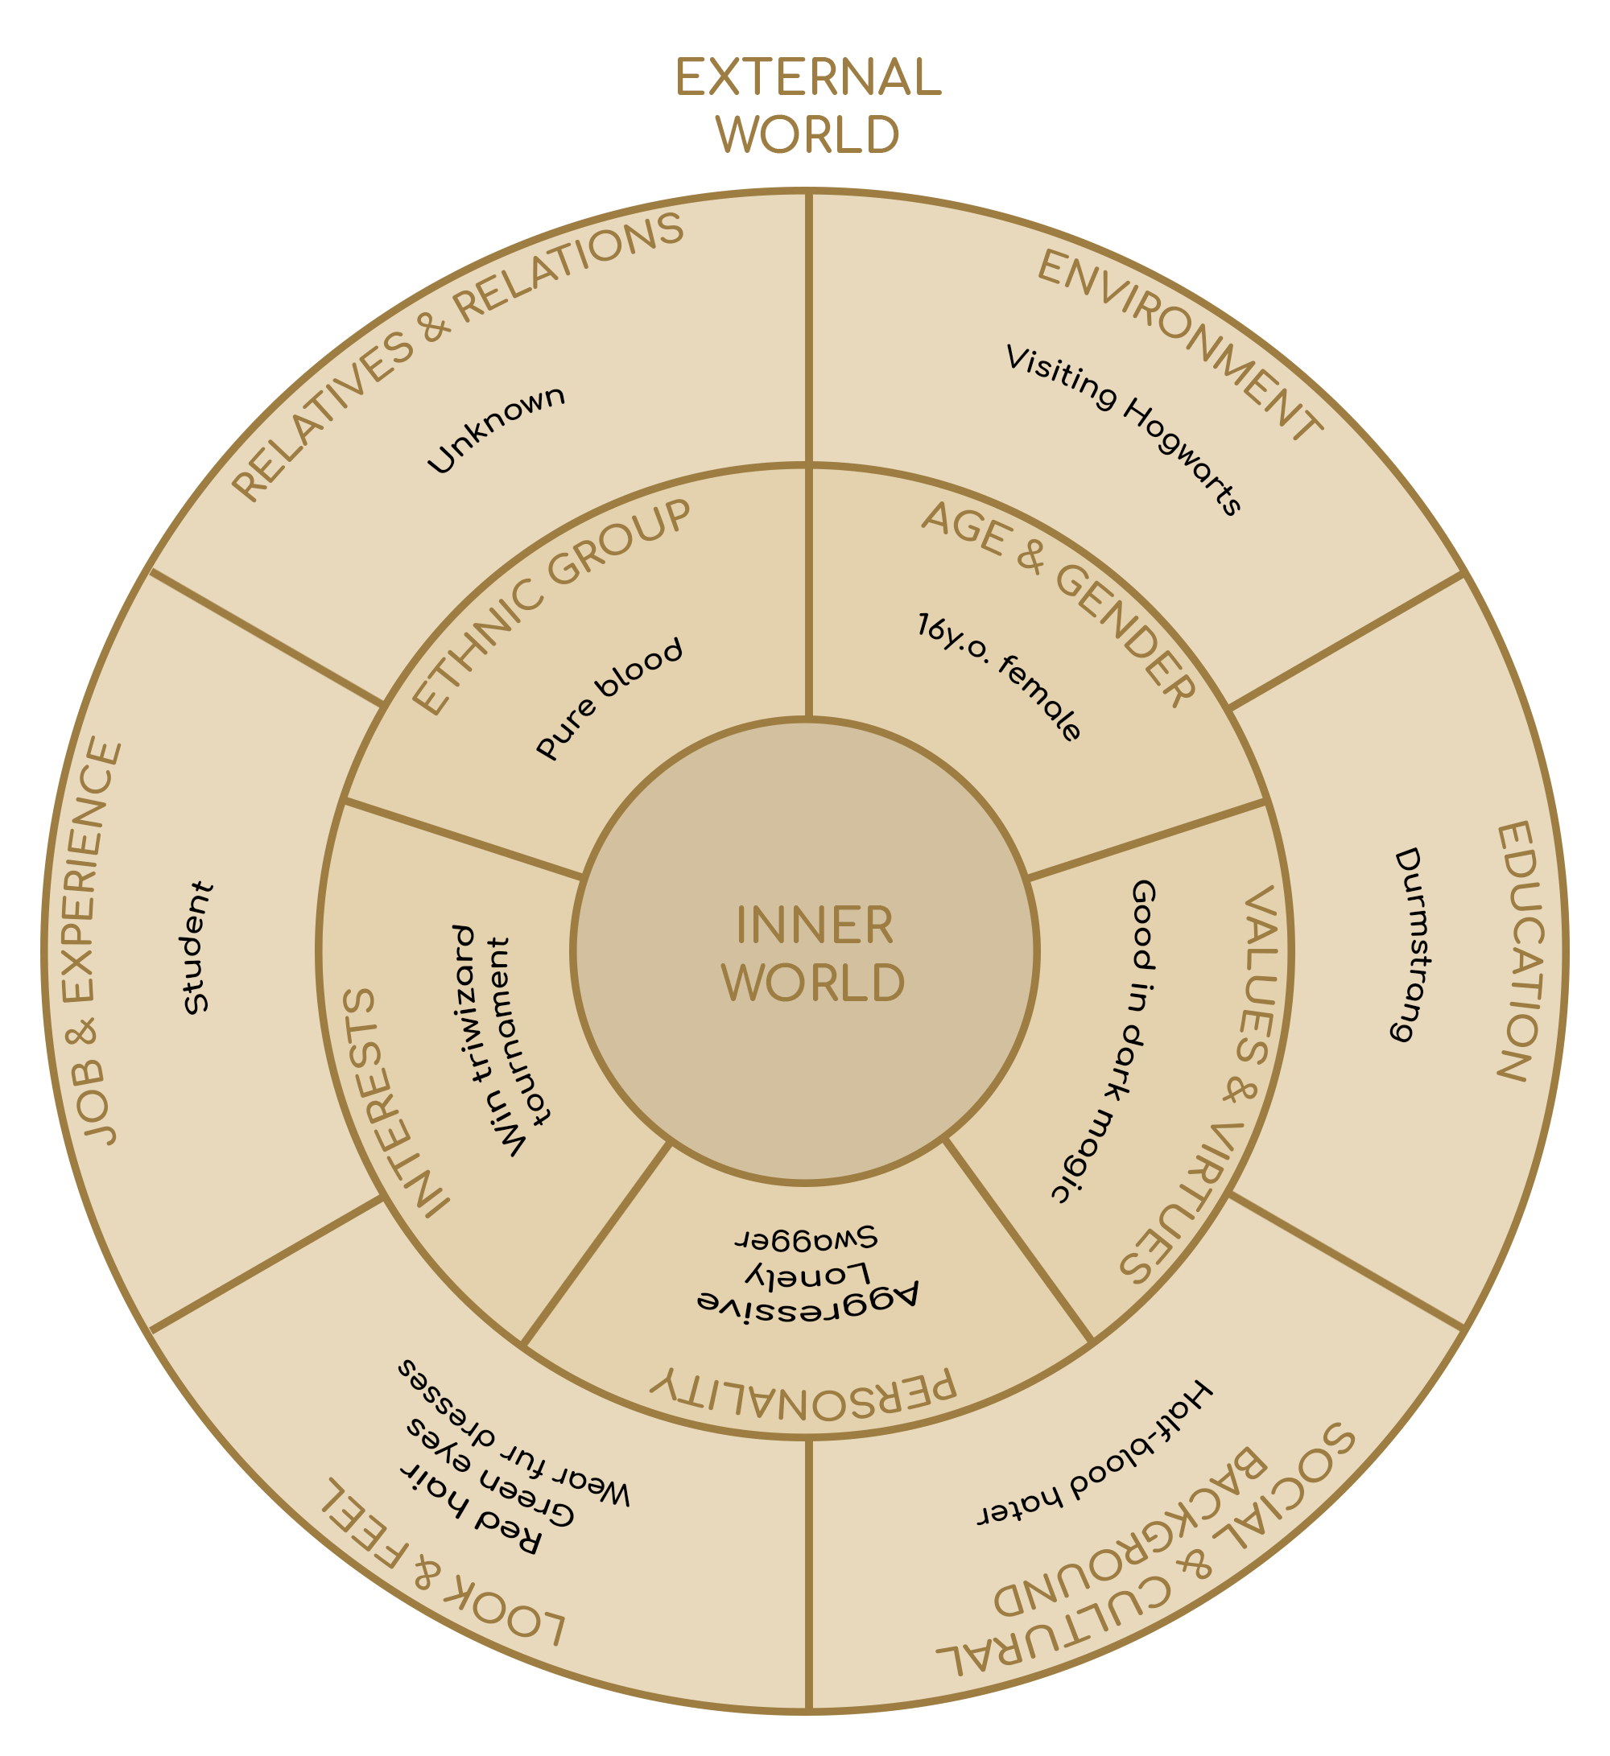

### RELATIONSHIP MAP

**ACT 2**

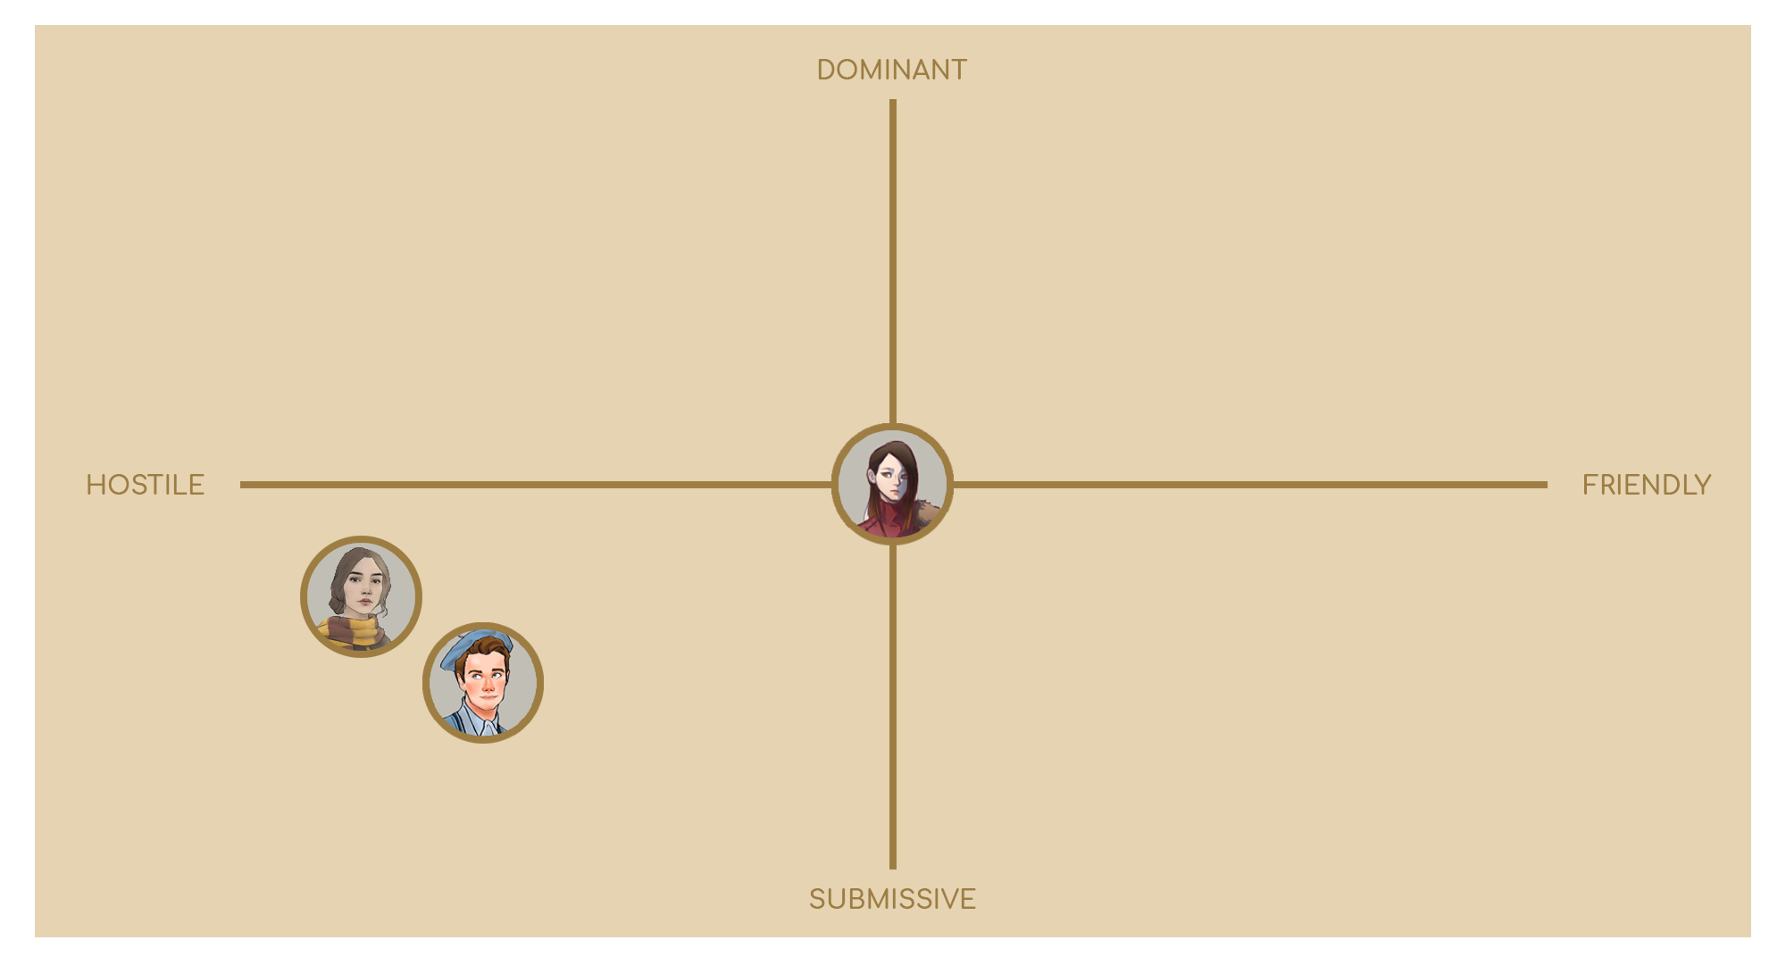

# 

# 

# 

# 

# 

# 

# WORLD DIAGRAM

# 

# 

# 

# 

# 

# 

# 

# 

# 

# 

# 

# 

# 

# GOAL OUTLINE

1. **WELCOME TO DIAGON ALLEY!**
   1. **Enter to Diagon Alley**
   2. **Finish School purchases**
      1. **Go to Pottidge’s Cauldron Shop**
      2. **Go to Quality Quidditch Supplies**
      3. **Go to Flourish & Blott’s**
      4. **Go to Madam Malkin’s Robes for All Occasions**
      5. **Go to Magical Menagerie**
      6. **Go to Ollivander’s**
   3. **Find what is going on at Gambol & Jape: Wizarding Joke Shop**
   4. **Take the train to Hogwarts**
2. **FIRST DAY OF SCHOOL** 
   1. **Go to your Common room**
   2. **Explore your room and go to sleep**
   3. **Go to lessons**
      1. **Follow spell lesson**
      2. **Follow potions lesson**
      3. **Follow transfiguration lesson**
   4. **Talk with Dumbledore in his office**
3. **CHOOSE YOUR WAY, MINERVA**
   1. **Follow transfiguration lesson**
   2. **Choose your way:**

**a) Sneak into the library at night**

**b) Go to duel room and learn new spells**

1. **INTO THE FOREST**
   1. **Go with Nott to the Forbidden Forest**
   2. **Reach the Aracnomantula’s den**
      1. **Defeat all the spiders**
      2. **Take some spider webs**
      3. **Overcome the Acromantula**
         1. **kill or spare it**
      4. **Take Aracnomantula’s eggs**
      5. **Go back to Nott**
   3. **Craft the potion recipe and try it**
2. **TRIWIZARD TOURNAMENT: KILL THAT BEAST**
   1. **Insert your name into the Goblet of Fire**
   2. **Explore the tournament area**
      1. **Speak with other challengers**
      2. **Speak with Nott**
   3. **Reach the entrance of the arena to start the first trial**
   4. **Retrieve the item protected by the beast**
3. **TRIWIZARD TOURNAMENT: CHIMAERA’S DUNGEON**
   1. **Discover the clues about the retrieved item**
   2. **Leave the camp to start the second trial**
   3. **Find a way out from the Chimaera’s dungeon**
      1. **Exceeds the first room**
      2. **Exceeds the second room**
      3. **Exceeds the third room**
4. **TRIWIZARD TOURNAMENT: FREE FOR ALL**
   1. **Reach the entrance of the arena to start the last trial**
   2. **Defeat the other challengers**
      1. **Reach the Triwizard Cup or retrieve it from the other wizard**
      2. **Win the Tournament!**
   3. **Celebrate your victory**
5. **NOT EVERYTHING IS AS IT SEEMS**
   1. **Tail Nott to find where he lives**
   2. **Explore the cave**
      1. **Defeat all the enemies**
   3. **Reach the hideout**
      1. **Inspect the room**
      2. **Read the Diary**
6. **THE DARK LADY AWAKENS**
   1. **Use the Felix Felicis potion**
   2. **Sneak in Dumbledore office**
      1. **Put the port key on his desk**
   3. **Wait Dumbledore in the cave to fight him**
7. **AS IT HAS ALWAYS BEEN**
   1. **Come back to Dumbledore**
      1. **Give the proof of Nott guiltiness to him**
   2. **Use the Felix Felicis potion**
   3. **Search the Nott secret room**
      1. **Defeat all the enemies**
8. **TIME END**
   1. **Defeat Dumbledore/Nott**

# 

# 

# LEVEL SCRIPT

Minerva wakes up in her tent with the mysterious crystal ball in her arms. She spent the evening trying to figure out how to get a clue from this strange object, without going much further than the inscription that appeared inside it after getting it in the arena: "*If the clue you want, in the nest of the phoenix you will watch*".

Just outside the tent, Minerva notices a letter leaning in front of the entrance. The envelope bears the initials of Theodore Nott. The letter reads:

*Dear Minerva,*

*I wish you good luck for the second rehearsal. I will not be able to assist you during the challenge but I know you will succeed.*

*Theodore Nott.*

[optional]

Minerva heads towards the big bonfire in the center of the camp. The fire has now faded for hours but the embers crackle incessantly. Minerva then rests the mysterious sphere on the hot embers. Suddenly the writing on the sphere changes, saying: "*The phoenix is rising, and his prize is giving*". The sphere then shatters and detects a small key with a coat of arms bearing the image of a phoenix.

Once ready, Minerva heads to the Triwizard arena, ready to face the second trial.

Heading to the arena, Minerva hears her name called from behind. It was Albus.

Albus: "*Minerva! yesterday you fought honorably, but the test you are about to face is very difficult, perhaps the most difficult of the three. You should take advantage of the knowledge learned during my transfiguration lessons.*"

Minerva:

1[Enigma resolved]- "*Thanks to this key perhaps I will succeed in the enterprise.*"

2-"*Don't tell me what I can or cannot do*".

3-"*I will keep it in mind.*"

4-"*You are a great example for me, thanks for your teachings.* "

[2]

Albus goes away regretful.

[1,3]

Albus accompanies her to the arena.

[4]

Albus gives a good luck charm to Minerva and continues with Minerva to the arena.

Once there, Minerva meets her two rivals. Astrid, having noticed that both her rivals are on the spot, starts mocking them:

Astrid: "*So you made it here too, what a surprise! Jacques, I see you didn't manage to get the key, without daddy you can't do much, can you?*"

Minerva:

1-"*Leave him alone, if he made it all the way here, he doesn't have to prove anything to you.*"

2-"*Remember that we too are the best of our schools*".

3-Minerva says nothing.

[1] Jacques: "*Be quiet! I don't need your half-blood help, I'll manage on my own.*"

[Enigma Solved]

[1] Astrid: "*Half-bloods are like this. Last night while you were sleeping, little girl, I already had the key in my hands, you proved to be of little value as I suspected*".

[2] Astrid: "*We'll see in the final challenge, losers!*"

[Enigma Unresolved]

[1] Astrid: "Jacques is right, you're on your own without the key. I'll wait for you at the exit."

[2] Astrid: "You may be the best, but you haven't solved the riddle."

[3] Astrid: "A son of a father and a mute half-blood, better and better..."

[Optional]

Minerva speaks with Jacques.

Minerva: "I hope you're not upset about Astrid..."

1 - "...You could have asked me for help, I would have given you a hand.

2 - "...but next time you could have tried harder..."

[1] Jacques: "I don't need your filthy help, go back to your Muggle parents."

[2] Jacques: "I don't need the key when I have my skills."

Jacques: "Now get out of the way..."

Jacques is interrupted by the announcement of the beginning of the trial.

Announcer: "Welcome to the second trial of the tournament Triwizard! This test will lead you inside the Chimaera dungeon. Will you be strong enough? Will you be fast enough? Will you be smart enough? You will need all your skills to get out of this dungeon full of danger. Good luck, challengers!"

Minerva heads towards the large door of the arena's basement. On the entrance door are represented a big phoenix fighting against the mighty Chimaera. Crossed the gate the three challengers are in front of their respective doors. Astrid turns towards minerva:

Astrid: "*Fear, McGonagall?*"

Minerva: "*That's obvious. Only a fool wouldn't have it.*"

The doors open wide with a dull noise and the announcer plays the trumpet to indicate the start of the test.

Minerva enters the first room. The room is full of enemies. Minerva can choose to go unnoticed or face them openly. After passing this first section, Minerva leaves the door and is in the entrance of the next test. Here, sitting and covered in blood, she finds Astrid, bored.

Astrid: "*Ah, you made it, as usual second. Now only that loser Jacques is missing. I hope he remains locked in the dungeon.*"

While Astrid finishes her speech, Jacques appears, fresh as if he had not even participated in the challenge.

Jacques: "*Here I am, you were talking about me?*"

Minerva hears the door of the second room open. This time she is in a room full of traps and pitfalls. Minerva with her acumen manages to overcome all the challenges and pitfalls in this location. She leaves the room and finds Jacques.

Jacques: "*So Astrid is still locked in the dungeon? I can't wait to see her face. Ah-a Ah-a Ah-a Ah-a*".

Minerva, satisfied with her result, notices a small groove next to her door. The wooden door that closes this compartment has carved the symbol of the phoenix.

[Enigma Solved]

The key of the phoenix starts to burn in Minerva's pocket. Once collected and inserted in the lock, the incisions present light up and reveal the contents of the compartment: Wit-Sharpening Potion.

Astrid leaves her door and seeing that her adversaries were waiting for her, she rushes towards Jacques angry and throws the key at his feet.

Astrid: "*I certainly don't need it, you stupid worm. And as for you*" referring to Minerva

[Enigma Solved]

Astrid: "*This potion won't do you any good. Any help is useless for a dirty half-breed like you!*"

Minerva: "*The facts prove otherwise, Astrid.*"

[Enigma Unresolved]

Astrid: "*I would never help a silly Muggle.*"

Minerva: "*No one wants your help, Astrid.*"

The last door opens, Minerva goes through a long corridor lit by flames and studded with statues of monsters and knights. At the end of the room there is a large statue: the Chimaera.

Minerva heads towards the imposing block of marble. The floor begins to shake. The flames go out. And the Chimaera begins to speak:

Chimaera: "*The Chimaera is here to challenge your brain, answer correctly and I will clear the way. Answer wrong and my anger will throw you away*".

Chimaera: "*here is the first riddle: They have certainly accompanied you on your travel, but if you have not tasted the true suffering, your eyes will not be able to unravel*"

[Minerva answers right]

Minerva: “*Thestral*”

[Minerva answers wrong]

The statues begin to come to life and attack Minerva who defeats them.

Chimaera: "*here is the second riddle: Weird hair, many tears ,it always cries, but it saves you many times*"

[Minerva answers right]

Minerva: “*Mandrake*”

[Minerva answers wrong]

The statues begin to come to life and some traps in the room are activated and attack Minerva who defeats them.

Chimaera: "*here is the third riddle: It can attack you, it has no arms or legs, but you put it anyway in your bag.*"

[Minerva answers right]

Minerva: “*Monster book*”

[Minerva answers wrong]

The statues begin to come to life and some traps in the room are activated.

The marble of the statue begins to crumble, the beast resumes its real form and attacks minerva...

[Minerva answers wrong]

along with the statues.

Defeating the enemies in the room, Minerva gets the tooth of the Chimaera as a prize and comes out of the narrow tunnel behind the lifeless body of the animal.

Minerva exits from the basement of the arena, in front of her she finds the crowd cheering her. The other participants have not yet left the arena.

After a few minutes you can hear the sound of an exhausted Chimaera and also Astrid comes out of the victorious arena door. When she sees that Minerva has left before her, she goes to meet her and asks her:

Astrid: "*Did you arrive before me?*"

Minerva:

1-"*That's obvious!*"

2-"*And it’s not the first time!*"

3- Minerva shows the tooth of the Chimaera satisfied.

[1,3] Astrid reaches her audience and shows the tooth

[2] Astrid goes back to her tent directly

Meanwhile, no noise comes from the third door. Jacques' friends start to approach the door to understand what is happening. At that point they hear a violent explosion that shatters the door into a thousand pieces. Jacques comes out of the room injured and limping and falls to the ground. The professors immobilize the Chimaera before he can do anything else. Jacques is rushed to the infirmary.

Minerva returns to her tent after the festivities. Sitting in front of it there is Theodore waiting for her.